1.6 Cooperation partners

Guidelines for chapter 2:
Please provide a plain-language summary of the research and structural objectives of the pro- posed Cluster of Excellence, in both English and German (text only, max. 3,000 characters each, including spaces. Please do not use special characters or images).
Estimation: In total, 1 page for this chapter.

7

- Summary of the proposal
  - English (max. 3000 characters incl. spaces)
Since the mid 20th century, crude oil has “fueled” the Anthropocene – literally through produc- tion of liquid energy carriers for mobility and transportation as well as by providing the crucial feedstock for the chemical value chain. The future will be renewable! Shaping a post-fossil era requires novel research concepts and breakthroughs in fundamental science to develop disrup- tive technologies as basis for a truly sustainable energy-chemistry interface within the planetary boundaries.
In this highly dynamic context, The Integrated Fuel & Chemical Science Center (FSC2) gen-
erates fundamental knowledge and novel scientific methods for the development of adaptive technical solutions to valorize renewable electricity and feedstocks into liquid energy carriers and chemicals in a systems approach. RWTH Aachen University and its strategic partners Forschungszentrum Jülich and Max Planck Institute for Chemical Energy Conversion integrate their competencies, methods, and infrastructures to understand, master, and design sustain- able processes for harnessing renewable energy in molecular form for distribution, storage, and use on a global scale.
The interdisciplinary Competence Areas (CAs) spanning the molecular, device, and systems levels, successfully established with a focus on fuels and combustion systems for on-road mo- bility over the last five years in The Fuel Science Center (FSC), form the backbone of a unique
research frame-work launching it to the next level as FSC2. All research activities are allo-
cated within five Strategic Research Areas (SRAs) stimulating disciplinary progress and foster- ing interdisciplinary integration. With the specific infrastructure of the partner institutions and the scientific profiles of the involved Principle Investigators, FSC2 is ideally positioned to align groundbreaking science with focal technology options in light of systems analysis. Continuing efforts from the previous phase focus on fuel design for low-carbon and low-emission liquid energy carriers. Nitrogen-based substances such as Ammonia are included newly to asses critically their potential as molecular energy carrier and chemical building block. In addition to thermal energy conversion, electrochemical devices for recuperating chemically stored energy are studied. The chemical value chain is explicitly addressed as a major area of application for novel synthetic pathways and catalytic processes. Analysis on a systems level is developed as integrative part to provide design criteria for sustainability and resilience within planetary boundaries.

9

2 Summary of the proposal

  - German (max. 3000 characters incl. spaces)
Seit Mitte des 20. Jahrhunderts hat Erdöl das Anthropozän ”befeuer” – buchstäblich durch die Produktion flüssiger Energieträger für Mobilität und Transport sowie durch die Bereitstel- lung des entscheidenden Rohstoffs für die chemische Wertschöpfungskette. Die Zukunft wird erneuerbar sein! Die Gestaltung einer postfossilen Ära erfordert neue Forschungskonzepte und Durchbrüche in der Grundlagenforschung, um disruptive Technologien zu entwickeln, die als Basis für eine wirklich nachhaltige Energie-Chemie-Schnittstelle innerhalb der planetaren Grenzen dienen.
In diesem hochdynamischen Kontext generiert The Integrated Fuel & Chemical Science Center (FSC2) grundlegendes Wissen und neue wissenschaftliche Methoden für die Entwicklung adap-
tiver technischer Lösungen zur Verwertung erneuerbarer Elektrizität und Rohstoffe in flüssige Energieträger und Chemikalien in einem systemischen Ansatz. Die RWTH Aachen University und ihre strategischen Partner, das Forschungszentrum Jülich und das Max-Planck-Institut für Chemische En- ergiekonversion, integrieren ihre Kompetenzen, Methoden und Infrastrukturen, um nachhaltige Prozesse zu verstehen, zu beherrschen und zu gestalten, die erneuerbare En- ergie in molekularer Form für die globale Verteilung, Speicherung und Nutzung nutzbar machen. Die interdisziplinären Competence Areas (CAs), die sich auf die molekularen, Geräte- und Sys- temebenen erstrecken und in den letzten fünf Jahren im The Fuel Science Center (FSC) mit Fokus auf Kraftstoffe und Verbrennungssysteme für den Straßenverkehr erfolgreich etabliert wurden, bilden das Rückgrat eines einzigartigen Forschungsrahmens, der als The Integrated
Fuel & Chemical Science Center (FSC2) auf die nächste Stufe gehoben wird. Alle Forschungsak-
tivitäten sind in fünf Strategic Research Areas (SRAs) eingebettet, die den disziplinären Fortschritt stimulieren und die interdisziplinäre Integration fördern. Mit der spezifischen Infrastruktur der Partnerinstitutionen und den wissenschaftlichen Profilen der beteiligten Hauptforscher ist FSC2 ideal positioniert, bahnbrechende Wissenschaft mit fokussierten Technologieoptionen im Lichte der Systemanalyse in Einklang zu bringen. Die fortgesetzten Bemühungen aus der vorheri- gen Phase konzentrieren sich auf das Kraftstoffdesign für kohlenstoffarme und emissionsarme flüssige Energieträger. Neu hinzugekommen ist Ammoniak, um dessen Potenzial als moleku- larer Energieträger und chemischer Baustein kritisch zu bewerten. Neben der thermischen En- ergiewandlung werden elektrochemische Geräte zur Rückgewinnung chemisch gespeicherter Energie untersucht. Die chemische Wertschöpfungskette wird ausdrücklich als Hauptanwen- dungsbereich für neue synthetische Wege und katalytische Prozesse angesprochen. Die Anal- yse auf Systemebene wird als integraler Bestandteil entwickelt, um Gestaltungskriterien für Nachhaltigkeit und Resilienz innerhalb der planetaren Grenzen bereitzustellen.

10

2.2 German (max. 3000 characters incl. spaces)

Guidelines for chapter 3:
Please provide a list of what you consider to be the most important research and structural objectives, up to a maximum of ten, which you intend to achieve through the Cluster of Excellence and by which its success should be measured.

Estimation: In total, a maximum of 5 pages for this chapter.

11

- Objectives of the Cluster of Excellence
  - Background and Motivation
The urgently required reduction of greenhouse gas emissions, especially CO2, has led to ex- tensive worldwide efforts aiming at net-zero and even carbon negative technologies. The de- ployment of renewable power generation is rapidly growing, mainly through installation of wind turbines and photovoltaic as cost-effective technologies for electricity generation (Lit). At the present time, biomass still provides the highest share of renewable energy and – albeit limited in availability – will remain an important component also in the future (Lit). With both green elec- tricity and biomass being highly fluctuating and delocalized resources, the dominating challenge for a global system based on renewable energy is its transportation and storage for effective use in the specific sectors of application (Lit).
Energy rich molecules – generated electrochemically or via green hydrogen - offer a key solution due to the high energy content of the chemical bond resulting in high volumetric and gravimetric energy density in liquid form. The integration of such energy carriers and intermediates into the sectors transport/mobility and chemical production holds major opportunities to “defossilize” these areas that are currently based almost exclusively on crude oil and responsible for a total of 24 % of the anthropogenic CO2 emissions (Lit OPEC). Synthetic hydrocarbons, methanol, and ammonia are emerging as promising options and technologies for their generation from the abundant feedstocks water, nitrogen, CO2 and biomass are demonstrated and deployed worldwide at rapidly increasing rate (Lit). Their use – directly or in upgraded form – as fuels in thermal or electrochemical energy conversion systems complements the direct electrification and use of hydrogen for powertrains in the transport and mobility sector. At the same time, they provide entry points into existing value chains and new production pathways for chemical products as essential pillar for a closed anthropogenic carbon cycle. Innovative technological solutions and the assessment of their ecological, economic, and social consequences are required urgently to validate and exploit the potential of this essential part of future energy systems.
In response to these research needs, The Integrated Fuel & Chemical Science Center (FSC2) will address challenges and explore opportunities of the emerging renewable energy-chemistry nexus from the molecules to the system level. The integral rather than competitive analysis of feedstocks from atmospheric, biogenic, and industrial sources will lead to a comprehensive design framework for “bio-hybrid fuels and chemicals”.

13

3 Objectives of the Cluster of Excellence

  - Vision and Mission
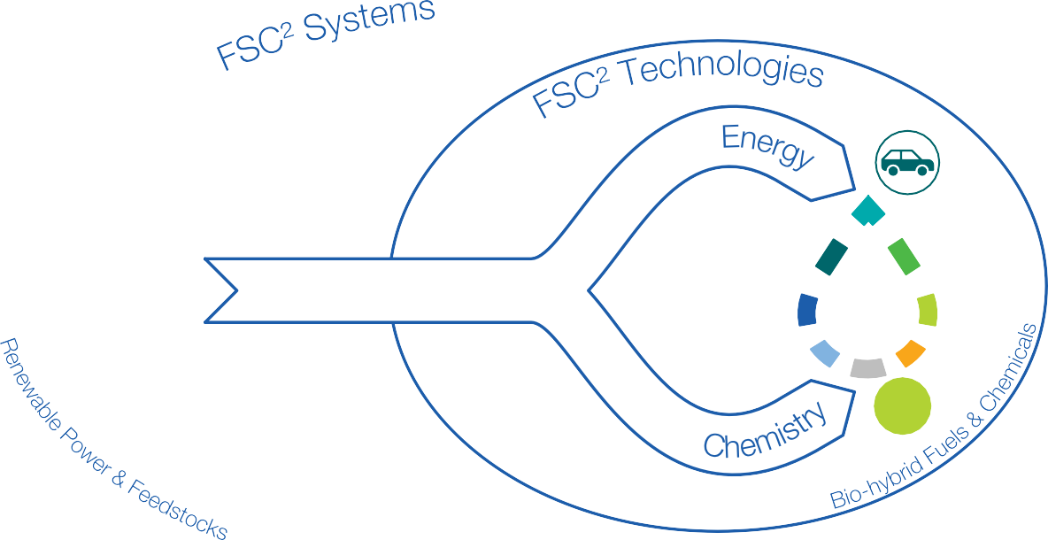
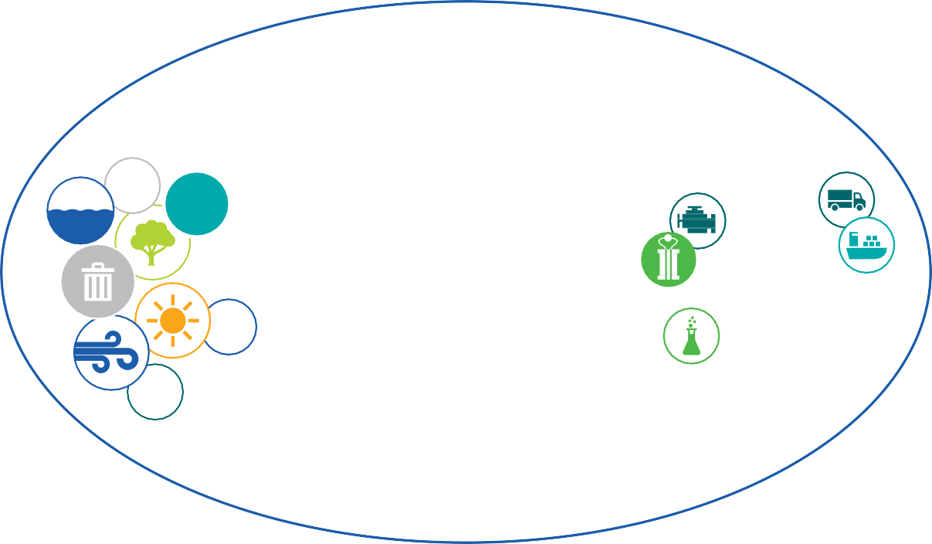
CO2
N2
e-
Energy & Chemistry Intermediates
e-
H2
The Integrated Fuel & Chemical Science Center generates fundamental knowledge and novel scientific methods
for the development of adaptive technical solutions to valorize renewable electricity and feedstocks into liquid energy carriers and chemicals
in a systems approach.
Figure 1: Vision and Mission of The Integrated Fuel & Chemical Science Center (FSC2)

Within FSC2, RWTH Aachen University (RWTH) and its strategic partners Forschungszentrum Jülich (FZJ) and Max Planck Institute for Chemical Energy Conversion (MPI CEC) take an integrated approach embracing natural sciences, engineering sciences, and social and economic sciences to encompass their competencies on the molecular, device, and systems level to understand, master, and design sustainable processes for har- nessing renewable energy in liquid energy carriers and chemicals. FSC2 will provide a science-driven framework for structural developments between RWTH, the FZJ of the Helmholtz-Association and the MPI CEC in the Max-Planck-Society. This includes agreements for open access to infrastructures as well as joint appointments for junior and se- nior researchers. It therefore integrates synergistically three different major institutions of the research and education system in Germany.

FSC2 has its roots in the Cluster of Excellence (CoE) The Fuel Science Center (FSC). A unique
interdisciplinary research culture was established overcoming disciplinary borders through com- posing the extended expertise of the research network in interdisciplinary Competence Areas (CAs) according to the time- and length-scales of the molecular, device, and systems level. Fo- cusing intially on the intricate relationship of combustion properties and the molecular struc- ture of carbon-based fuels as common denominator a “fuel design process” was successfully established for the first time. A substantial number of high-level publications from interdisciplinary and interinstitutional teams showcases the collaborative spirit as basis to enter into unchartered scientific territory. During this development, the synergistic potential of the studied production technologies for energy carries as well as chemical products became increasingly obvious as reflected by life cycle assessment and socio-economic analyses. This background places the partner institutions and network of Principal Investigators (PIs) now in a unique position to align groundbreaking science on the production of fuels and chemicals with focal technology options for molecule-based energy conversion systems in light of systems analysis. To express the approach of Fundamental Science embracing Systems thinking for Fuels and Chemicals within an integrated Center structure, we have chosen FSC2 as acronym, illustrating simultaneously the successful branding and the adaptivity of the research framework to new directions.
Based on the previous scientific and structural achievements (see Chapter 4.2 and 4.3), FSC2 is able to respond to the dynamic in the global energy system by expanding and refocusing its research program into novel areas. We propose to carry the unique interdisciplinary approach to a next level by (i) expanding the systematic bio-hybrid design process to integrate fuel and chemical production explicitly, (ii) addressing nitrogen-based substances and in particular ammonia newly in the integrated fuel and chemical design process, (iii) extending the technologies for fuel conversion by considering fuel compatibility with existing vehicle fleets as well as energy conversion in fuel cells for future propulsion systems, (iv) integrating innovations in individual catalysis disciplines strategically in optimized process chains, and (v) intensifying the development and use of digitalized research data management and machine learning methods.
In particular, FSC2 will address the following key questions originating from the vision and mission outlined above:
    - How can global energy and material cycles be made adaptive and resilient, while fulfilling all three dimensions of sustainability – ecological, economic, and social? Current research often focuses on individual aspects of fuel and chemical conversion systems, e.g., individual levels of the system, or certain aspects of sustainability. Moreover, disruptions to the systems’ supply and operation are often neglected, and the dynamics of the ongoing long-term transformation towards climate-neutrality are not sufficiently covered. Therefore, there is a need for an integrated approach to design and operate these systems to be both resilient to withstand and quickly recover from disruptions, and adaptive to adjust to variability in supply and demand and long-term transformation processes. The approach must encompass all dimensions of sustainability at every level, from individual processes to the broader supply chain and system level.
    - How can translational catalytic processes at the direct interface of energy and feedstocks
be designed to cope with the dynamics and variations of their supply? In current catalysis research on renewable carbon feedstocks, there is a strong focus on developing novel trans- formations often using simple and pure model compounds. However, an envisaged process requires the additional fulfilment of certain catalyst performance criteria in terms of activity,
15

3 Objectives of the Cluster of Excellence

selectivity, and stability when dealing with real starting materials. Solvents and reactants characteristics need to be integrated with downstream processing and product isolation to achieve minimal energy use and environmental footprint.
    - How can chemical, biochemical, and electrochemical transformations for the manipulation of C – H, C – C, C – O and C – N bonds be interlinked to open concatenated synthetic pathways to fuels and chemicals? The transformations of bio-based, CO₂-based and nitrogen-based building blocks are usually addressed by the individual catalysis disciplines of molecular, heterogeneous, electro-, or bio- catalysis. To establish effective connections between starting materials and desired molecular architectures, however, the transformation steps need to be designed and developed with a focus on the transfer points of intermediate products, reaction media and the recycling of the catalyst system from the beginning. Therefore, the selection of the most appropriate catalytic discipline is not determined solely by the evaluation of the individual catalytic transformation, but rather by the most efficient contribution within a transformation cascade of concatenated catalytic steps.
    - How does the molecular structure of carbon-based fuels impact on efficiency and emissions
upon recuperation of the chemically stored energy in fleet-compatible thermal or future elec- trical propulsion systems? In the current phase, all degrees of freedom of bio-hybrid fuel molecules and molecularly controlled combustion systems were exploited to achieve the high- est possible efficiency with near-to-zero pollutant emissions. The task now is to transfer this knowledge to the optimization of existing propulsion systems with the associated tight con- straints regarding possible modifications. Research into electrochemical energy conversion is currently focused almost exclusively on hydrogen as an energy carrier. Here, the potential of direct liquid fuel cells is now to be unlocked through the integrated fuel design process.
    - How can engines and devices be designed to exploit ammonia as fuel most effectively? Am-
monia’s low reactivity and its tendency to form oxides of nitrogen pose major challenges to achieving high energetic efficiency and low emissions in thermochemical utilization. Solutions will be developed combining the molecular-torch concept with utilizing partial in-process re- forming to hydrogen and innovations in exhaust gas aftertreatment specifically for the very potent greenhouse gas N2O.

  - Objectives
Based on the vision as well as resulting scientific challenges and key questions, FSC2 defines its scientific and structural objectives (see Table 3.3).

16

3.3 Objectives

Table 3.3.1: Objectives of The Integrated Fuel & Chemical Science Center

Scientific Objectives
Enable optimal overall efficiency, from co-production of chemicals & fuels via common intermediates to propulsion in existing & novel propulsion technologies; this is done by developing & combining cutting- edge methods from molecular design, propulsion equipment design, production process development,
and machine learning.
Design of sustainable pathways from renewable energy and carbon resources, nitrogen and hydrogen to chemical and energy intermediates eventually allowing the synergistic production of bio-hybrid fuels
and chemicals.
Concatenated bio-, chemo- and electrocatalytic transformations for bio-hybrid fuels and chemicals will be enabled by integrated catalyst, reactor and process development, complemented by the tai- lored interplay with modeling approaches, ultimately leading to the establishment of digital tools for the predictive catalyst-process design and their validation in view of feedstock variation and energy
fluctuation in post-fossil value chains (translation).
Enable beyond 50 % energy conversion efficiencies and near-zero pollutant emissions by develop-
ing bio-hybrid-fuel based fleet-compatible and novel engine concepts with advanced molecularly- controlled combustion and aftertreatment technologies.
Exploit the potential of novel carbon- and ammonia-based fuel cell concepts as well as ammonia- fueled combustion engines enabled by fundamental understanding of the involved thermochemical
and electrochemical processes.
Design of resilient and sustainable global conversion systems that integrate FSC2 pathways, fuels, and chemicals with competing and synergistic pathways and products via systemic risks, stakeholder
perspectives, policies, and sustainability criteria.
Structural Objectives
FSC2 furnishes a world-class research environment through the convergence of disciplinary research and strategic collaboration of RWTH with the Max Planck Institute for Chemical Energy Conversion and the Helmholtz-Center Jülich; it will generate prolific and highest quality scientific output including joint publications, enable the individual researchers to take a leading role in the scientific community,
and provide a stimulating framework for translational research.
Strategic renewal of FSC2 through 8 reappointments of established lighthouse professorships, and 5 strategic new appointments as tenure track and lighthouse professorships in inter-faculty and inter- institutional frameworks strengthen the core competences as well as new strategic research areas,
particularly in the field of digital chemistry and fuel cells beyond hydrogen.
Accelerated talent development of early career researchers is accomplished through a comprehensive set of developmental measures and an individualized curriculum organized within FSC2 Research
School.
Fostering an inclusive and diverse research culture with the aim to increase the diversity within the team across disciplines and hierarchies of FSC2 by establishing a tailor-made research-oriented di- versity approach. This includes a diversity survey based on various diversity categories (e.g., gender,
national background, family duties) enabling an intersectional diversity perspective to gain insights in challenges and opportunities of the team structure, according to the needs formulated by the members
of the cluster.

17

