Letter of Intent
to submit a proposal for a Cluster of Excellence

General Instructions
The Letters of Intent of the universities to submit proposals for a Cluster of Excellence are non- binding, are not reviewed and only serve to plan the review process.

Submission is requested

- for renewal proposals: by 4 pm on 29 January 2024.

- for establishment proposals: by 4 pm on 15 April 2024.

The information contained is preliminary and may differ from the actual proposal.

Please use the following template for the Letter of Intent, delete the instructions (in grey font) and convert the document to PDF format. Create a PDF file without password protection and without restrictions regarding reading, copying and printing. The PDF should be submitted via elan as “correspondence” regarding the draft proposal/establishment proposal, respectively. Please note that Letters of Intent can only be submitted by the spokespersons.

Submission of the Letter of Intent via elan:
  - Please log in to your elan account. Only the spokesperson(s) can submit the Letter of Intent.
  - Select “Proposal Submission” - “Proposal Overview/Renewal Proposal”.
  - Search for the Cluster of Excellence (draft) proposal in the list and select “Continue”.
  - Click the button next to “Form for submitting comments, inquiries and additions to the DFG Head Office” to start the online form.
  - Upload the Letter of Intent as a PDF file and select “Continue”.
  - Select “Send” to send the form to the DFG Head Office.
  - You will be provided with a PDF summary of your submitted form for download and you will receive an automatic confirmation e-mail.

Letter of Intent to submit a proposal for a Cluster of Excellence

- Proposal Type
☐ New proposal
Reference number of draft proposal: EXC 3 /0
☒ Renewal proposal
Reference number of establishment proposal: EXC 2186/1

Title in German and English
Das Integrated Fuel & Chemical Science Center
Adaptive Umwandlungssysteme für erneuerbare Energieträger und Chemikalien

The Integrated Fuel & Chemical Science Center
Adaptive Conversion Systems for Sustainable Energy Carriers and Chemicals

Applicant university/universities and spokesperson(s)

Managing University
RWTH Aachen University

Spokesperson(s)

Authorised spokesperson at the Managing University | Univ.-Prof. Dr.-Ing. (USA) Stefan Pischinger

Further spokesperson(s) | Institution
Univ.-Prof. Dr. rer. nat. Walter Leitner | RWTH Aachen University  Max Planck Institute for  Chemical Energy Conversion

Participating Institutions

Participating institutions | Location
Forschungszentrum Jülich (FZJ) | Jülich
Max Planck Institute for  Chemical Energy Conversion | Mülheim a.d.R.

Summary of the Proposal
Since the mid 20th century, crude oil fuels the Anthropocene – literally through production of liquid energy carriers for mobility and transportation as well as by providing the crucial feedstock of carbon and hydrogen for the chemical value chain. Despite world-wide efforts to reduce greenhouse gas emissions, the demand for crude oil is predicted to reach an all-time high exceeding the gigantic production of 100 barrel per day in the coming years. The scenarios for the reduction towards net-zero GHG-emissions require a range of measures centered around the global availability of renewable energy. The resulting de-carbonization of the energy sector imposes challenges and opportunities for the de-fossilization of the sectors mobility/transportation and chemistry where direct electrification is difficult or even impossible due to the indispensable need for carbon. Shaping a post-fossil area at the interface of energy and chemistry therefore requires novel research concepts and breakthroughs in fundamental science as basis for disruptive technologies that will result in major societal and economic transformations.
In the context of this dynamic development of utmost importance for a sustainable future, „The Integrated Fuel & Chemical Science Center” (FSC²) generates fundamental knowledge and novel scientific methods for the development of adaptive technical solutions to valorize renewable electricity and feedstocks into liquid energy carriers and chemicals in a systems approach. RWTH Aachen University (RWTH) and its strategic partners Forschungszentrum Jülich (FZJ) and Max Planck Institute for Chemical Energy Conversion (MPI CEC) take an integrated approach to encompass their competencies on the molecular, device, and systems level to understand, master, and design sustainable processes to harness renewable energy in chemical energy carriers and products.
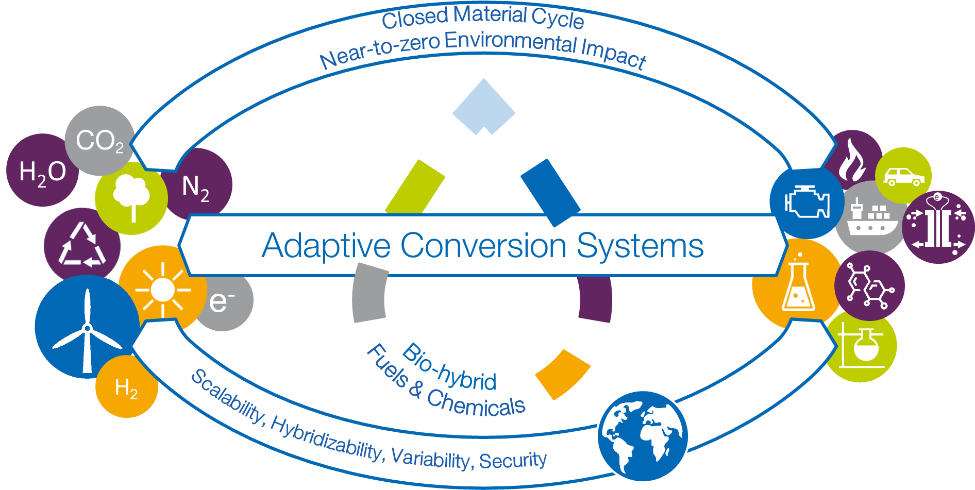
Figure 1: Vision of FSC² „The Integrated Fuel & Chemical Science Center generates fundamental knowledge and novel scientific methods for the development of adaptive technical solutions to valorize renewable electricity and feedstocks into liquid energy carriers and chemicals in a systems approach”

FSC² has its roots in the CoE „Tailor-made Fuels from Biomass (TMFB)“ at RWTH Aachen. A unique interdisciplinary collaboration was established between combustion engineering, chemical engineering, chemistry, and biology using the intricate relation between combustion properties and the molecular structure of advanced bio-based fuels as common denominator. By strategic development of projects and structural measures, a fundamental understanding of a „fuel design“ was successfully established for the first time. In the subsequent CoE, FSC was able to establish the broader field of „fuel science“ internationally by overcoming disciplinary borders through composing the extended expertise of the network in “Competence Areas” according to the time- and length-scales of the molecular, device, and systems level. While carbon-based fuels were still at the center of the research activities, their application in advanced engine technologies and their „bio-hybrid“ production based on biomass as well as CO₂ as alternative carbon sources could thus be envisaged. Expanding the research topics beyond the technosphere identified adaptivity as important design criteria to cope with the dynamics and variations in energy and feedstock supply at the interface between the energy and chemistry sectors.
The successfully established concept of interdisciplinary Competence Areas (CAs) and their effective and dynamic interconnection now form the backbone of the fully integrated research framework of FSC² to address adaptively the challenges resulting from the “defossilization” of energy carriers and chemicals. All research activities and projects are allocated within Strategic Research Areas (SRAs) where they absorb and vice versa stimulate the disciplinary progress of the individual PIs, thus constantly augmenting the CAs. With the specific infrastructure of the partner institutions and the scientific profiles of the involved PIs, FSC² is ideally positioned to align the focal technology options for post-fossil molecular energy carriers and products. Continuing efforts will be devoted to fuel design for low-carbon and low-emission liquid energy carriers. Ammonia is now included as molecular energy carrier and thermal as well as electro-chemical devices for recuperation of the chemical stored energy are being studied. The chemical value chain is addressed explicitly as major area of application for the novel synthetic pathways and catalytic processes. Analysis on a systems level is developed as integrative part to provide design criteria for sustainability and anti-fragility.

The Strategic Research Areas for FSC² will address the following key questions originating from the vision and mission outlined above:
- How can global energy and material cycles be made adaptive and resilient so that they fulfill all three dimensions of sustainability - ecological, economic and social?
- How can translational catalytic processes at the direct interface of energy and feedstocks be designed to cope with the dynamics and variations of their supply?
- How does the molecular structure of carbon-based fuels impact on efficiency and emissions upon recuperation of the chemically stored energy in backward-compatible thermal or future electrical propulsion systems?
- How can engines and devices be designed to exploit ammonia as fuel most effectively?
- How can chemical, biochemical, and electrochemical transformations for the manipulation of C-O and C-N bonds be interlinked to open concatenated synthetic pathways to fuels and chemicals?
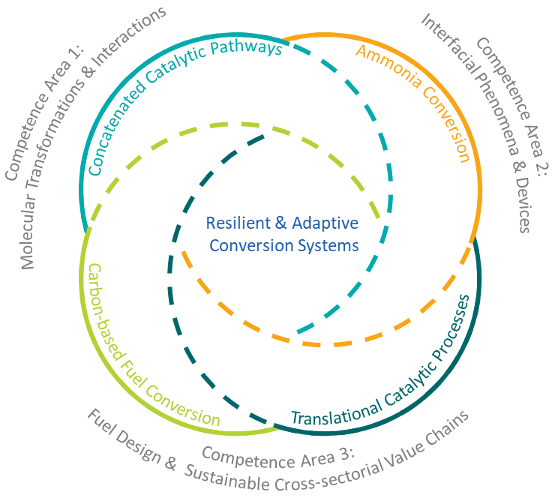
Figure 3: Strategic Research Areas (SRAs)
The SRAs are bridged via general design challenges that will be addressed in flexible working groups as the research progress develops. This includes for example the integration of production pathways and propulsion properties for the C-based fuel design, the fundamental mechanisms of electrochemical ammonia activation for energy or synthetic applications as well as the seemingly contradicting goals of integration for process chains and flexibility of individual process steps. The central platform for the discussion, analysis, and continuous adjustment of the overall research program in light of its mission and vision is provided in the „Systems Design Forum“.

Principal Investigators

No. | Principal investigators | Location/Institution | Field of expertise | Position
1 | Jun.-Prof. Dr. phil. Katrin Arning | Aachen, RWTH | Risk Perception and Communication | W1/temporary
2 | Prof. Dr.-Ing. Dipl.-Wirt.Ing. Niklas von der Aßen | Aachen, RWTH | Technical Thermodynamics | W3/permanent
3 | Univ.-Prof. Dr.-Ing. Lars M. Blank | Aachen, RWTH | Applied Microbiology | W3/permanent
4 | Prof. Dr. rer. nat. habil. Rüdiger Eichel | Jülich, FZJ | Fundamental Electrochemistry | W3/permanent
 |  | RWTH | Material and Process of Electrochemical Energy Storage and Conversion
5 | Univ.-Prof. Dr. Kathrin Greiff | Aachen, RWTH | Anthropogenic Material Cycles | W3/permanent
6 | Univ.-Prof. Dr. rer. nat. Sonja Herres-Pawlis | Aachen, RWTH | Chair of Bioinorganic Chemistry | W3/permanent
7 | Prof. Dr.-Ing. Karl Alexander Heufer | Aachen, RWTH | Chair of High Pressure Gas Dynamics | W3/permanent
8 | Univ.-Prof. Dr.-Ing. Andreas Jupke | Aachen, RWTH | Chair of Fluid Process Engineering | W3/permanent
9 | Univ.-Prof. Dr. rer. nat. Jürgen Klankermayer | Aachen, RWTH | Institute of Technical and Macromolecular Chemistry (Translational Molecular Catalysis) | W3/permanent
10 | Univ.-Prof. Dr. rer. nat. habil. Lars Lauterbach | Aachen, RWTH | Synthetic Microbiology Teaching and Research Area | W2/permanent
11 | Univ.-Prof. Dr. rer. nat. Walter Leitner | Aachen, RWTH | Institute of Technical and Macromolecular Chemistry (Technical Chemistry and Petrochemistry) | W3/permanent
 |  | Mühlheim a.d.R., MPI CEC | Chemical Energy Conversion
12 | Prof. Dr. techn. Karl Mayrhofer | Erlangen, FZJ | Helmholtz Institute Erlangen-Nürnberg for Renewable Energy | W3/permanent
13 | Univ.-Prof. Dr. rer. nat. Anna Mechler | Aachen, RWTH | Chair of Electrochemical Reaction Engineering | W3/temporary
14 | Univ.-Prof. Alexander Mitsos, Ph.D. | Aachen, RWTH | Chair of Process Systems Engineering | W3/permanent
 |  | Jülich, FZJ | Energy Systems Engineering
15 | Univ.-Prof. Dr. rer. nat. Regina Palkovits | Aachen, RWTH | Institute of Technical and Macromolecular Chemistry (Heterogeneous Catalysis and Technical Chemistry) | W3/permanent
16 | Univ.-Prof. Dr.-Ing. (USA) Stefan Pischinger | Aachen, RWTH | Chair of Thermodynamics of Mobile Energy Conversion Systems | W3/permanent
17 | Univ.-Prof. Dr.-Ing. Heinz Pitsch | Aachen, RWTH | Institute for Combustion Technology | W3/permanent
18 | Univ.-Prof. Dr. rer. nat. Dörte Rother | Jülich, FZJ | Institute of Bio- and Geosciences | W3/permanent
19 | Univ.-Prof. Dr.  Franziska Schoenebeck | Aachen, RWTH | hair of Organic Chemistry I and Institute of Organic Chemistry | W3/permanent
20 | Univ.-Prof. Dr. phil. Carmen Leicht-Scholten | Aachen, RWTH | Chair of Gender and Diversity in Engineering | W3/permanent
21 | Univ.-Prof. Dr. rer. nat. Ulrich Simon | Aachen, RWTH | Chair of Inorganic Chemistry and Electrochemistry | W3/permanent
22 | Prof. Dr. Siegfried R. Waldvogel | Mühlheim a.d.R., MPI CEC | Chemical Energy Conversion | W3/permanent
23 | Univ. Prof. Dr. rer. pol. Grit Walther | Aachen, RWTH | Chair of Operations Management | W3/permanent
24 | Univ.-Prof. Dr.-Ing. Matthias Wessling | Aachen, RWTH | Chair of Chemical Process Engineering | W3/permanent
25 | Univ.-Prof. Dr. rer. nat. Mirijam Zobel | Aachen, RWTH | Institute of Crystallography | W3/permanent

Fields of Research

No. | Fields of research
1 | 403-02 Technische Chemie
2 | 404-02 Technische Thermodynamik
3 | 404-01 Energieverfahrenstechnik
4 | 403-01 Chemische und Thermische Verfahrenstechnik
5 | 404-04 Strömungs- und Kolbenmaschinen
6 | 321-02 Organische Molekülchemie - Synthese, Charakterisierung
7 | 204-02 Mikrobielle Ökologie und Angewandte Mikrobiologie
8 | 327-01 Elektronenstruktur, Dynamik, Simulation
9 | 112-03 Betriebswirtschaftslehre
10 | 111-02 Empirische Sozialforschung

Please list up to ten disciplines primarily involved in the Cluster of Excellence, using the five- digit codes of the DFG subject structure: www.dfg.de/en/dfg-profile/statutory-bodies/review- boards/structure. Please prioritise entries in descending order of relevance.

Key Methods and Models

No. | Method / Model
1 | Chemical Synthesis and Molecular Systems
2 | Multifunctional Catalyst Design
3 | Electrochemistry and Electrocatalysis
4 | Multi-Scale Reactor Design
5 | Fluid Dynamics and Reactive Flows
6 | Process Systems Engineering
7 | Combustion Science and Engineering
8 | Exhaust Gas Aftertreatment Systems
9 | Sustainability Assessment and Acceptance Modelling
10

Collaborations/Conflicts of Interest

No. | Collaboration partners | Location/Institution
1 | Claire Adjiman | United Kingdom, Imperial College London
2 | Paul Alivasatos | USA, University of California
3 | Frédéric Allain | Switzerland, ETH Zürich
4 | Paul Anastas | USA, Yale University
5 | Markus Appel | France, ILL
6 | Matthias Arenz | Switzerland, Universität Bern
7 | Antonio Attili | United Kingdom, University of Edinburgh
8 | Adisa Azapagic | United Kingdom, The University of Manchester
9 | Marco Baratieri | Italy, Universität Bozen
10 | André Bardow | Switzerland, ETH Zürich
11 | Dirk Bartel | Germany, U Magdeburg
12 | Matthias Bauer | Germany, Universität Paderborn
13 | Frank Bauer | Germany, U Stuttgart
14 | Andrea Beck | Germany, Universität Stuttgart
15 | Malte Behrens | Germany, Universität Kiel
16 | Alexis Bell | USA, Energy Biosc. Institute
17 | Fabrizio Bisetti | USA, University of Texas
18 | Anja Böckmann | France, IBCP Lyon
19 | André L. Boehman | USA, University of Michigan
20 | Benjamin Böhm | Germany, TU Darmstadt
21 | Esin Ilhan Caarls | Netherlands, Eindhoven University
22 | Liming Cai | China, Tongji University
23 | Chang-Hyuck Choi | South Korea, Gwangju Institute of Science and Technology
24 | Avelino Corma | Spain, Universidad de Valencia
25 | Björn Corzilius | Germany, Rostock University
26 | Francesco Creta | Italy, University of Rome
27 | Gabriel J. Cuello | France, ILL
28 | Alberto Cuoci | Italy, Politecnico di Milano
29 | Henry Curran | Ireland, Galway University
30 | Manuel Dahmen | Germany, FZJ
31 | Bassam Dally | Saudi Arabia, KAUST
32 | Mara de Joannon | Italy, STEMS
33 | Serena deBeer | Germany, Max Planck Institute for Chemical Energy Conversion
34 | Dario R. Dekel | Israel, Technion
35 | Pascale Domingo | France, INSA Rouen
36 | Andreas Dreizler | Germany, TU Darmstadt
37 | Hellmut Eckert | Brasil, Universidade de São Paulo
38 | Andreas Erbe | Norway, Norwegian University of Science and Technology
39 | Gerhard Erker | Germany, Westfälische Wilhelms-Universität Münster
40 | Matthias Ernst | Switzerland, ETH Zürich
41 | Bastian Etzold | Germany, Technische Universität Darmstadt
42 | Roland Faller | USA, University of California
43 | Tiziano Faravelli | Italy, Politecnico di Milano
44 | Ravi Fernandes | Germany, PTB
45 | Federica Ferraro | Germany, TU Braunschweig
46 | Anna Fischer | Germany, Albert-Ludwigs-Universität
47 | Henry Fischer | France, ILL
48 | Hubert Gasteiger | Germany, Technische Universität München
49 | Markus Geimer | Germany, KIT
50 | Roger Gläser | Germany, Universität Leipzig
51 | Eirini Goudeli | Australia, University of Melbourne
52 | William Green | USA, MIT
53 | Temistocle Grenga | United Kingdom, Southhampton University
54 | Stefan Grimme | Germany, University of Bonn
55 | Alon Grinberg Dana | Israel, Technion
56 | Jan-Dierk Grunwaldt | Germany, KIT
57 | Peter Güntert | Switzerland, ETH Zürich
58 | Fabien Halter | France, University of Orleans
59 | Nils Hansen | USA, Sandia National Laboratories
60 | Christian Hasse | Germany, TU Darmstadt
61 | Marco Haumann | Germany, FAU
62 | Andreas Herrmann | Germany, DWI
63 | Henner Hollert | Germany, Goethe Universität
64 | Graham Hutchings | United Kingdom, Cardiff University
65 | Johannes Janicka | Germany, TU Darmstadt
66 | Frederic Jaouen | France, Université de Montpellier
67 | Gunnar Jeschke | Switzerland, ETH Zürich
68 | Agnes Jocher | Germany, TU München
69 | Yiguang Ju | USA, Princeton
70 | Sebastian Kaiser | Germany, Universität Duisburg-Essen
71 | Tina Kapser | Germany, Universität Paderborn
72 | Jay Keasling | USA, University of California
73 | Rhett Kempe | Germany, UBT
74 | Andreas Kempf | Germany, Universität Duisburg-Essen
75 | Berthold Kersting | Germany, University of Leipzig
76 | Reza Kholgy | Canada, Carleton University
77 | Markus Klein | Germany, Universität der Bundeswehr München
78 | Wolfgang Kleist | Germany, TU Kaiserslautern
79 | Stephen J. Klippenstein | USA, Argonne National Laboratories
80 | Katharina Kohse-Höinghaus | Germany, Uni Bielefeld
81 | Marc Koper | Netherlands, Leiden University
82 | Amit Kumar | Canada, University of Alberta
83 | Georg Künze | Germany, Leipzig University Medical School
84 | Alexei Lapkin | United Kingdom, University of Cambridge
85 | Vincent Le Chenadec | France, Gustave Eiffel University
86 | Gregory T. Linteris | USA, NIST
87 | Alfred Ludwig | Germany, Ruhr-Universität Bochum
88 | Thomas Lunkenbein | Germany, FHI
89 | Ulrich Maas | Germany, Karlsruhe Institute of Technology
90 | Andreas Magerl | Germany, FAU
91 | Detlef Markus | Germany, PTB
92 | Beat H. Meier | Switzerland, ETH Zürich
93 | Tatiana Minav | Finnland, Tampere University
94 | Micheal Mueller | USA, Princeton University
95 | Graham J. Nathan | Australia, University of Adelaide
96 | Daniel Pak | Germany, Universität Siegen
97 | Alessandro Parente | Belgium, Free University of Brussels
98 | Brian Pauw | Germany, BAM
99 | Matteo Pelucchi | Italy, Politecnico di Milano
100 | Bo Persson | Germany, FZ Jülich
101 | GiovanniMaria Piccini | Italy, UNIMORE
102 | Andrij Pich | Germany, DWI
103 | Martyn Poliakoff | United Kingdom, The University of Nottingham
104 | Dierk Raabe | Germany, Max-Planck-Institut für Eisenforschung GmbH
105 | Ortwin Renn | Germany, IASS
106 | Roland Riek | Switzerland, ETH Zürich
107 | William L. Roberts | Saudi Arabia, KAUST
108 | Yuri Roman | USA, Massachusetts Institute of Technology
109 | S. Mani Sarathy | Saudi Arabia, KAUST
110 | Philippe Sautet | USA, UCLA
111 | Taraneh Sayadi | France, Sorbonne University
112 | Thomas Scheibel | Germany, University of Bayreuth
113 | Viktor Scherer | Germany, RU Bochum
114 | Christina Scheu | Germany, Max-Planck-Institut für Eisenforschung GmbH
115 | Martin Schiemann | Germany, RU Bochum
116 | Robert Schlögl | Germany, Max-Planck-Institut für Chemische Energiekonversion
117 | Hans-Joachim Schmid | Germany, Universität Paderborn
118 | Wolfgang Schuhmann | Germany, Ruhr-Universität
119 | Christof Schulz | Germany, Universität Duisburg-Essen
120 | Ferdi Schüth | Germany, Max-Planck-Institut für Kohlenforschung
121 | Artur Schweidtmann | Netherlands, TU Delft
122 | Jürgen Senker | Germany, UBT
123 | Yang Shao-Horn | USA, Massachusetts Institute of Technology
124 | Mirko Skiborowski | Germany, SVT, TU Hamburg
125 | Irina Smirnova | Germany, TVT, TU Hamburg
126 | Evan Spruijt | Netherlands, Radboud University Nijmegen
127 | Greg Stephanopoulos | USA, Massachusetts Institute of Technology
128 | Peter Strasser | Germany, Technische Universität Berlin
129 | Elena Sturm | Germany, LMU
130 | Juha Tanskanen | Finland, University of Oulu
131 | Edson Ticianelli | Brasil, University of São Paulo
132 | Adri van Duin | USA, Pennsylvania State University
133 | Toon Verstraelen | Belgium, University of Ghent
134 | Luc Vervisch | France, INSA Rouen
135 | Birgit Vogel-Heuser | Germany, TU München
136 | Peter Wasserscheid | Germany, FAU
137 | Hiroaki Watanabe | Japan, Fukuoka Unviersity
138 | Jürgen Weber | Germany, TU Dresden
139 | Bert Weckhuysen | Netherlands, Universität Utrecht
140 | Charles Westbrook | USA, University of California
141 | Martin Wollschläger | Germany, TU Dresden
142 | Dzmitry Zaitsau | Germany, University of Rostock
143 | Tao Zhang | China, Dalian Institute of Chemical Phsysics

Persons who are to be excluded from the Review Panel

No. | Person | Location/Institution
1 | <person> | <location, institution>
2 | <person> | <location, institution>
3 | <person> | <location, institution>

Signatures

place and date | signature
name
(Authorised spokesperson of the managing university)
place and date | signature
name
(Rector / president of the managing university)
place and date | signature
name
(Rector / president of other applicant universities)
place and date | signature
name
(Rector / president of other applicant universities)
.

