Letter of Intent
to submit a proposal for a Cluster of Excellence

General Instructions
The Letters of Intent of the universities to submit proposals for a Cluster of Excellence are non- binding, are not reviewed and only serve to plan the review process.

Submission is requested

- for renewal proposals: by 4 pm on 29 January 2024.

- for establishment proposals: by 4 pm on 15 April 2024.

The information contained is preliminary and may differ from the actual proposal.

Please use the following template for the Letter of Intent, delete the instructions (in grey font) and convert the document to PDF format. Create a PDF file without password protection and without restrictions regarding reading, copying and printing. The PDF should be submitted via elan as “correspondence” regarding the draft proposal/establishment proposal, respectively. Please note that Letters of Intent can only be submitted by the spokespersons.

Submission of the Letter of Intent via elan:
  - Please log in to your elan account. Only the spokesperson(s) can submit the Letter of Intent.
  - Select “Proposal Submission” - “Proposal Overview/Renewal Proposal”.
  - Search for the Cluster of Excellence (draft) proposal in the list and select “Continue”.
  - Click the button next to “Form for submitting comments, inquiries and additions to the DFG Head Office” to start the online form.
  - Upload the Letter of Intent as a PDF file and select “Continue”.
  - Select “Send” to send the form to the DFG Head Office.
  - You will be provided with a PDF summary of your submitted form for download and you will receive an automatic confirmation e-mail.

Letter of Intent to submit a proposal for a Cluster of Excellence

- Proposal Type
☐ New proposal
Reference number of draft proposal: EXC 3 /0
☒ Renewal proposal
Reference number of establishment proposal: EXC 2186/1

Title in German and English
The Integrated Fuel & Chemical Science Center
Adaptive Umwandlungssysteme für erneuerbare Energieträger und Chemikalien

The Integrated Fuel & Chemical Science Center
Adaptive Conversion Systems for Sustainable Energy Carriers and Chemicals

Applicant university/universities and spokesperson(s)

Managing University
RWTH Aachen University

Spokesperson(s)

Authorised spokesperson at the Managing University | Prof. Dr.-Ing. (USA) Stefan Pischinger

Further spokesperson(s) | Institution
Prof. Dr. rer. nat. Walter Leitner | RWTH Aachen University  Max Planck Institute for  Chemical Energy Conversion

Participating Institutions

Participating institutions | Location
Forschungszentrum Jülich (FZJ) | Jülich
Max Planck Institute for  Chemical Energy Conversion | Mülheim a.d.R.

Summary of the Proposal
Since the mid 20th century, crude oil and natural gas have “fueled” the Anthropocene – literally through production of liquid energy carriers for mobility and transportation as well as by providing the crucial feedstock of carbon and hydrogen for the chemical value chain. Despite world-wide efforts to reduce the associated greenhouse gas emissions, the demand for crude oil is predicted to reach an all-time high exceeding the gigantic production of 100 barrel per day in the coming years. The scenarios for the reduction towards net-zero GHG-emissions require a range of measures centered around the global availability of renewable energy. The resulting de-fossilization of the energy sector imposes challenges and opportunities for the sectors mobility/transportation and chemistry where direct electrification is difficult or even impossible due to the indispensable need for carbon. Shaping a post-fossil area at the interface of energy and chemistry therefore requires novel research concepts and breakthroughs in fundamental science as basis for disruptive technologies that will result in major societal and economic transformations.
In the context of this dynamic development of utmost importance for a sustainable future, „The Integrated Fuel & Chemical Science Center” (FSC²) generates fundamental knowledge and novel scientific methods for the development of adaptive technical solutions to valorize renewable electricity and feedstocks into liquid energy carriers and chemicals in a systems approach. RWTH Aachen University (RWTH) and its strategic partners Forschungszentrum Jülich (FZJ) and Max Planck Institute for Chemical Energy Conversion (MPI CEC) take an integrated approach to encompass their competencies on the molecular, device, and systems level to understand, master, and design sustainable processes to harness renewable energy in chemical energy carriers and products.
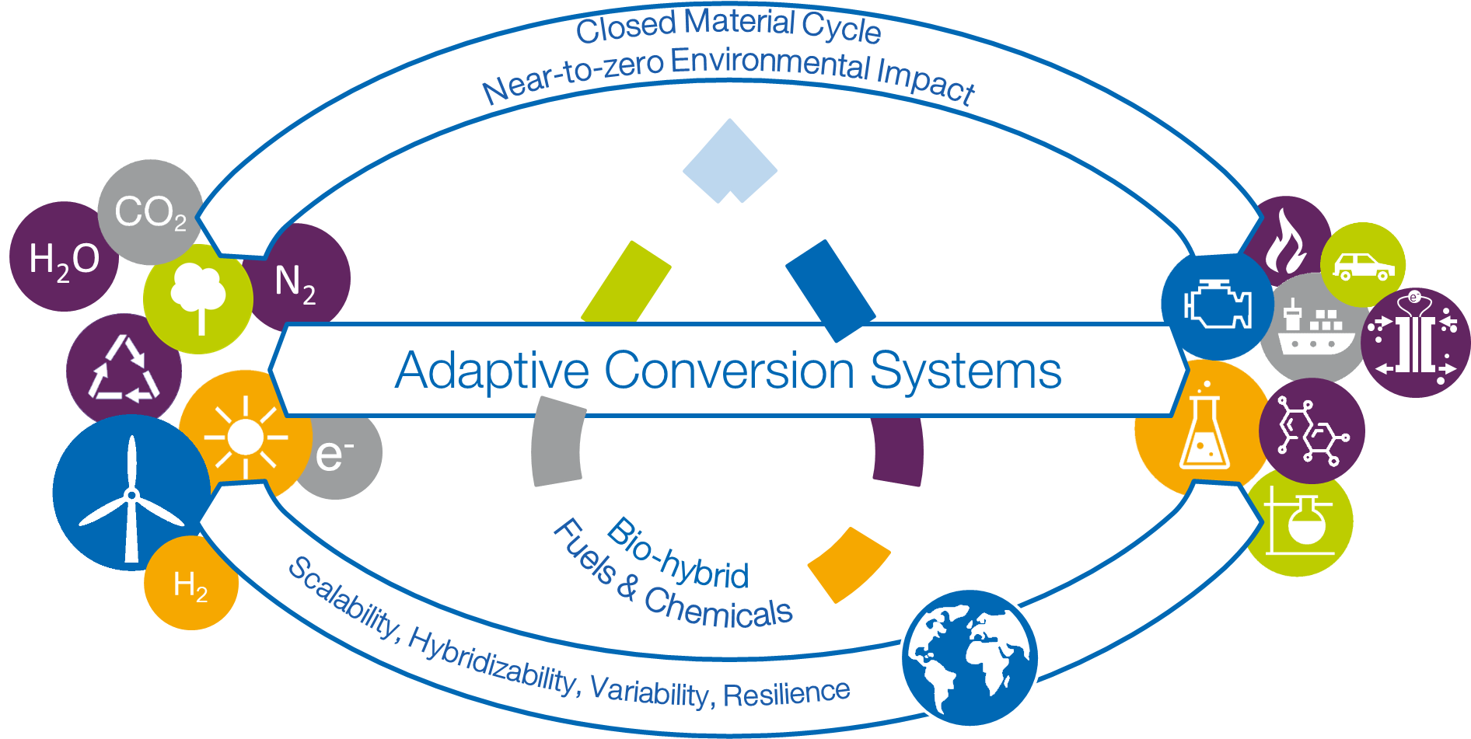
Figure 1: Vision of FSC² „The Integrated Fuel & Chemical Science Center generates fundamental knowledge and novel scientific methods for the development of adaptive technical solutions to valorize renewable electricity and feedstocks into liquid energy carriers and chemicals in a systems approach”

FSC² has its roots in the CoE „Tailor-made Fuels from Biomass (TMFB)“ at RWTH Aachen. A unique interdisciplinary collaboration was established between combustion engineering, chemical engineering, chemistry, and biology using the intricate relation between combustion properties and the molecular structure of advanced bio-based fuels as common denominator. By strategic development of projects and structural measures, a fundamental understanding of „fuel design“ was successfully established for the first time. The subsequent CoE, “The Fuel Science Center (FSC)” was able to establish the broader field of „fuel science“ internationally by overcoming disciplinary borders through composing the extended expertise of the network in interdisciplinary “Competence Areas” according to the time- and length-scales of the molecular, device, and systems level. While carbon-based fuels were still at the center of the research activities, their application in advanced engine technologies and their „bio-hybrid“ production based on biomass as well as CO₂ as alternative carbon sources could thus be envisaged. Expanding the research topics beyond the technosphere identified adaptivity as important design criteria to cope with the dynamics and variations in energy and feedstock supply at the interface between the energy and chemistry sectors.
The successfully established concept of interdisciplinary Competence Areas (CAs) and their effective and dynamic interconnection now form the backbone of the unique research framework of “The Integrated Fuel & Chemical Science Center” (FSC²) to address adaptively the challenges resulting from the “defossilization” of energy carriers and chemicals. All research activities and projects are allocated within Strategic Research Areas (SRAs) where they absorb and vice versa stimulate the disciplinary progress of the individual PIs, thus constantly augmenting the CAs. With the specific infrastructure of the partner institutions and the scientific profiles of the involved PIs, FSC² is ideally positioned to align groundbreaking science with focal technology options for post-fossil molecular energy carriers and products. Continuing efforts will be devoted to fuel design for low-carbon and low-emission liquid energy carriers. Ammonia is now included as molecular energy carrier and chemical building block. In addition to thermal combustion, electro-chemical devices for recuperation of the chemical stored energy are being studied. The chemical value chain is addressed explicitly as major area of application for the novel synthetic pathways and catalytic processes. Analysis on a systems level is developed as integrative part to provide design criteria for sustainability and resilience.

The Strategic Research Areas for FSC² will address the following key questions originating from the vision and mission outlined above:
- How can global energy and material cycles be made adaptive and resilient so that they fulfill all three dimensions of sustainability - ecological, economic and social?
- How can translational catalytic processes at the direct interface of energy and feedstocks be designed to cope with the dynamics and variations of their supply?
- How does the molecular structure of carbon-based fuels impact on efficiency and emissions upon recuperation of the chemically stored energy in backward-compatible thermal or future electrical propulsion systems?
- How can engines and devices be designed to exploit ammonia as fuel most effectively?
- How can chemical, biochemical, and electrochemical transformations for the manipulation of C-O and C-N bonds be interlinked to open concatenated synthetic pathways to fuels and chemicals?
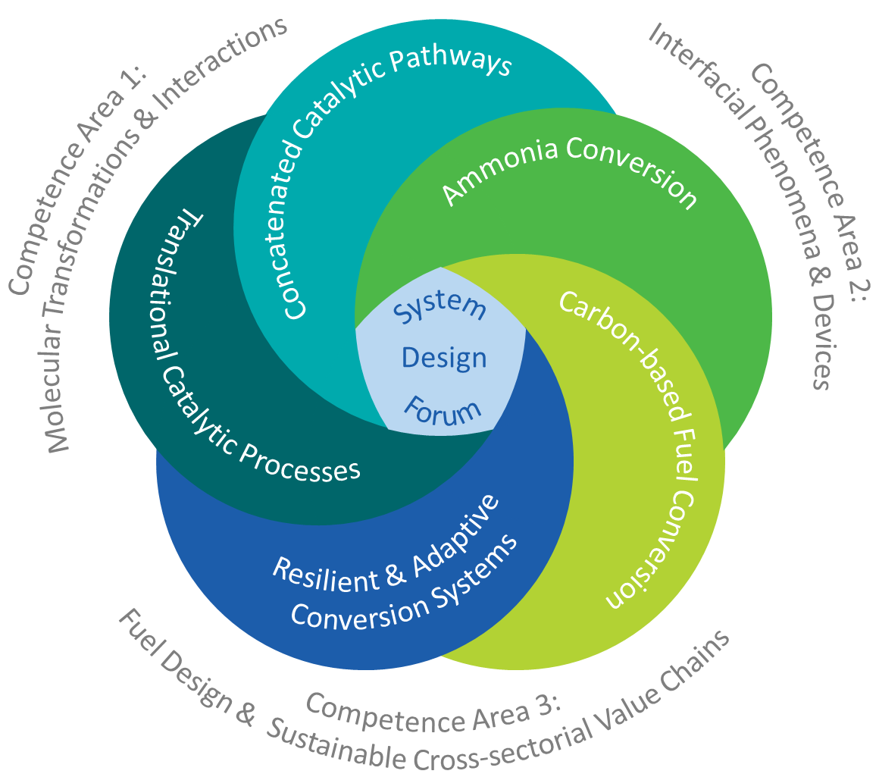
Figure 3: The integrated framework of the five Strategic Research Areas (SRAs) embedded
within the Competence Areas (CAs)
The SRAs are bridged via general design challenges that will be addressed in flexible working groups as the research program develops. This includes for example the integration of production pathways and propulsion properties for the C-based fuel design, the fundamental mechanisms of electrochemical ammonia activation for energy or synthetic applications, as well as the seemingly contradicting goals of integration for process chains and flexibility of individual process steps. A common platform for the scientific exchange and continuous adjustment of the overall research program in light of its mission and vision is provided in the „Systems Design Forum“, where the progress of the five SRAs and the working groups is biannually reported and discussed.
The 25 core PIs represent the three CAs and define the thematic focus within the SRAs. The project work is, however, based on a much larger network of scientific excellence and methodological expertise through about 15 associated PIs. All PIs have the same rights and responsibilities within the Cluster, creating the necessary critical mass and structural impact among the partner institutions. The resulting flexibility ensures continuing rejuvenation of the network of PIs including strategic appointments and early succession models. A major component are the support of early career academics opening new career paths across the institutional landscape.

Principal Investigators

No. | Principal investigators | Location/Institution | Field of expertise | Position
1 | Jun.-Prof. Dr. phil. Katrin Arning | Aachen, RWTH | Risk Perception and Communication | W2/tenure track
2 | Prof. Dr.-Ing. Dipl.-Wirt.Ing. Niklas von der Aßen | Aachen, RWTH | Technical Thermodynamics | W3/permanent
3 | Prof. Dr.-Ing. Lars M. Blank | Aachen, RWTH | Applied Microbiology | W3/permanent
4 | Prof. Dr. rer. nat. habil. Rüdiger Eichel | Jülich, FZJ | Fundamental Electrochemistry | W3/permanent
 |  | RWTH | Material and Process of Electrochemical Energy Storage and Conversion
5 | Prof. Dr. rer. nat. Kathrin Greiff | Aachen, RWTH | Anthropogenic Material Cycles | W3/permanent
6 | Prof. Dr. rer. nat. Sonja Herres-Pawlis | Aachen, RWTH | Bioinorganic Chemistry | W3/permanent
7 | Prof. Dr.-Ing. Karl Alexander Heufer | Aachen, RWTH | High Pressure Gas Dynamics | W3/permanent
8 | Prof. Dr.-Ing. Andreas Jupke | Aachen, RWTH | Fluid Process Engineering | W3/permanent
9 | Prof. Dr. rer. nat. Jürgen Klankermayer | Aachen, RWTH | Translational Molecular Catalysis | W3/permanent
10 | Prof. Dr. rer. nat. habil. Lars Lauterbach | Aachen, RWTH | Synthetic Microbiology | W2/permanent
11 | Prof. Dr. rer. nat. Walter Leitner | Aachen, RWTH | Technical Chemistry and Petrochemistry | W3/permanent
 |  | Mühlheim a.d.R., MPI CEC | Molecular Catalysis
12 | Prof. Dr. techn. Karl Mayrhofer | Erlangen, FZJ | Electrocatalysis | W3/permanent
13 | Prof. Dr. rer. nat. Anna Mechler | Aachen, RWTH | Electrochemical Reaction Engineering | W2/temporary
14 | Prof. Alexander Mitsos, Ph.D. | Aachen, RWTH | Process Systems Engineering | W3/permanent
 |  | Jülich, FZJ | Energy Systems Engineering
15 | Prof. Dr. rer. nat. Regina Palkovits | Aachen, RWTH | Heterogeneous Catalysis and Technical Chemistry | W3/permanent
 |  | Jülich, FZJ | Sustainable Hydrogen Economy

No. | Principal investigators | Location/Institution | Field of expertise | Position
16 | Prof. Dr.-Ing. (USA) Stefan Pischinger | Aachen, RWTH | Thermodynamics of Mobile Energy Conversion Systems | W3/permanent
17 | Prof. Dr.-Ing. Heinz Pitsch | Aachen, RWTH | Combustion Technology | W3/permanent
18 | Prof. Dr. rer. nat. Dörte Rother | Jülich, FZJ | Synthetic Enzyme Cascades | W3/permanent
19 | Prof. Dr. rer. nat.  Franziska Schoenebeck | Aachen, RWTH | Organic Chemistry | W3/permanent
20 | Prof. Dr. phil. Carmen Leicht-Scholten | Aachen, RWTH | Gender and Diversity in Engineering | W3/permanent
21 | Prof. Dr. rer. nat. Ulrich Simon | Aachen, RWTH | Inorganic Chemistry and Electrochemistry | W3/permanent
22 | Prof. Dr. rer. nat. Siegfried R. Waldvogel | Mühlheim a.d.R., MPI CEC | Electrosynthesis | W3/permanent
23 | Univ. Prof. Dr. rer. pol. Grit Walther | Aachen, RWTH | Operations Management | W3/permanent
24 | Prof. Dr.-Ing. Matthias Wessling | Aachen, RWTH | Chemical Process Engineering | W3/permanent
25 | Prof. Dr. rer. nat. Mirijam Zobel | Aachen, RWTH | Crystallography and X-Ray Spectroscopy | W3/permanent

Fields of Research

No. | Fields of research
1 | 403-02 Technische Chemie
2 | 404-01 Energieverfahrenstechnik
3 | 404-02 Technische Thermodynamik
4 | 403-01 Chemische und Thermische Verfahrenstechnik
5 | 404-04 Strömungs- und Kolbenmaschinen
6 | 321-01 Anorganische Molekülchemie - Synthese, Charakterisierung
7 | 321-02 Organische Molekülchemie - Synthese, Charakterisierung
8 | 204-01 Stoffwechselphysiologie, Biochemie und Genetik der Mikroorganismen
9 | 112-03 Betriebswirtschaftslehre
10 | 111-02 Empirische Sozialforschung

Key Methods and Models

No. | Method / Model
1 | Chemical Synthesis and Molecular Systems
2 | Multifunctional Catalyst Design
3 | Electrochemistry and Electrocatalysis
4 | Metabolic and Bioprocess Engineering
5 | Multi-Scale Reactor Design
6 | Fluid Dynamics and Reactive Flows
7 | Process Systems Engineering
8 | Combustion Science and Engineering
9 | Exhaust Gas Aftertreatment Systems
10 | Sustainability and Risk Assessment

Collaborations/Conflicts of Interest

No. | Collaboration partners | Location/Institution
1 | Claire Adjiman | United Kingdom; Imperial College London
2 | Kareem Ahmed | USA; Univ. Central Florida
3 | Manfred Aigner | Germany; DLR
4 | Paul Alivasatos | USA; University of California
5 | Frédéric Allain | Switzerland; ETH Zürich
6 | Mohamed R. E. Aly | Egypt; Port Said University
7 | Paul Anastas | USA; Yale University
8 | Jakob Andreasson | Czech Republic; ELI
9 | Antonio Andreini | Italy; University Florence
10 | Corina Andronescu | Germany; Univ. Duisburg-Essen
11 | Ulf-Peter Apfel | Germany; RUB and UMSICHT
12 | Markus Appel | France; ILL
13 | Matthias Arenz | Switzerland; Universität Bern
14 | Antonio Attili | United Kingdom; University of Edinburgh
15 | Frank Atzler | Germany; TU Dresden
16 | Alexander Auer | Germany; MPI KoFo
17 | Ilka Axmann | Germany; Universität Düsseldorf
18 | Adisa Azapagic | United Kingdom; The University of Manchester
19 | Julien Bachmann | Germany; FAU Erlangen- Nürnberg
20 | Michael Baldea | USA; TUTA
21 | Marco Baratieri | Italy; Universität Bozen
22 | André Bardow | Switzerland; ETH Zürich
23 | Dirk Bartel | Germany; U Magdeburg
24 | Frank Bauer | Germany; U Stuttgart
25 | Matthias Bauer | Germany; Universität Paderborn
26 | Andrea Beck | Germany; Universität Stuttgart
27 | Tristan Becker | Germany; Technische Universität Dresden
28 | Malte Behrens | Germany; Universität Kiel
29 | Alexis Bell | USA; Energy Biosc. Institute
30 | Ian H. Bell | USA; National Institute of Standards and Technology
31 | Sarah BenAmor | Canada; University of Ottawa
32 | Lorenz T. Biegler | USA; CMU
33 | Pegah Bineshpour | Iran; College of Engineering
34 | Fabrizio Bisetti | USA; University of Texas
35 | Bastian Bloombach | Germany; TUM
36 | Anja Böckmann | France; IBCP Lyon
37 | André L. Boehman | USA; University of Michigan
38 | Benjamin Böhm | Germany; TU Darmstadt
39 | Dominik Bongartz | Belgium; KU Leuven
40 | Joakim Bood | Sweden; Lund University
41 | Uwe Bornscheuer | Germany; University Greifswald
42 | Irina Borodina | Dänemark; DTU
43 | Michael Bortz | Germany; Fraunhofer ITWM
44 | Christian Bressler | Germany; XFEL
45 | Stefanie Bröring | Germany; Ruhr-Universität Bochum
46 | Bruno Bühler | Germany; UFZ
47 | Esin Ilhan Caarls | The Netherlands; Eindhoven University
48 | Liming Cai | China; Tongji University
49 | M. Campanella | United Kingdom; University of London, Queen Mary
50 | Campbell D. Carter | USA; Air Force Research Lab
51 | André Casal Kulzer | Germany; Universität Stuttgart
52 | Benoit Chachuat | United Kingdom; Imperial College London
53 | Henry Chapman | Germany; CFEL
54 | Athanasios Chatzitakis | Norway; Universität Oslo
55 | George Chen | China; Tsinghua University
56 | Peirong Chen | China; SCUT
57 | Chang-Hyuck Choi | South Korea; Gwangju Institute of Science and Technology
58 | E. Colacino | France; Université de Montpellier
59 | Avelino Corma | Spain; Universidad de Valencia
60 | Björn Corzilius | Germany; Rostock University
61 | Francesco Creta | Italy; University of Rome
62 | Gabriel J. Cuello | France; ILL
63 | Alberto Cuoci | Italy; Politecnico di Milano
64 | Henry Curran | Ireland; Galway University
65 | Bassam Dally | Saudi Arabia; KAUST
66 | Mara de Joannon | Italy; STEMS
67 | Serena deBeer | Germany; Max Planck Institute for Chemical Energy Conversion
68 | Dario R. Dekel | Israel; Technion
69 | Uwe Deppenmeyer | Germany; Universität Bonn
70 | Hyungrok Do | South Korea; Seoul National University
71 | Linda Doerrer | USA; Boston University
72 | Pascale Domingo | France; INSA Rouen
73 | Libor Dostal | Czech Republic; Universität Pardubice
74 | Andreas Dreizler | Germany; TU Darmstadt
75 | Matthias Drieß | Germany; TU Berlin
76 | Eliabeth Dütschke | Germany; Fraunhofer ISI
77 | Birgitta Ebert | Australien; University of Queensland
78 | Hellmut Eckert | Brasil; Universidade de São Paulo
79 | Helmut Eichlseder | Austria; TU Graz
80 | Peter Eilts | Germany; TU Braunschweig
81 | Suleyman Er | The The Netherlands; DIFFER
82 | Andreas Erbe | Norway; Norwegian University of Science and Technology
83 | Gerhard Erker | Germany; Westfälische Wilhelms-Universität Münster
84 | Matthias Ernst | Switzerland; ETH Zürich
85 | Erik Esche | Germany; TU Berlin
86 | Bastian Etzold | Germany; Technische Universität Darmstadt
87 | Roland Faller | USA; University of California
88 | Tiziano Faravelli | Italy; Politecnico di Milano
89 | Michael Feldbrügge | Germany; Universität Düsseldorf
90 | Claudio Ferdeghini | The Netherlands; Maastricht University
91 | Ravi Fernandes | Germany; PTB
92 | Federica Ferraro | Germany; TU Braunschweig
93 | Anna Fischer | Germany; Albert-Ludwigs-Universität
94 | Asja Fischer | Germany; Ruhr-Universität Bochum
95 | Henry Fischer | France; ILL
96 | B. Furman | Poland; Polish Academy of Sciences
97 | Amparo Galindo | United Kingdom; Imperial College London
98 | Hubert Gasteiger | Germany; Technische Universität München
99 | Klaus-Peter Geigle | Germany; DLR Institute for Combustion Technology
100 | Markus Geimer | Germany; KIT
101 | Peter Gerlinger | Germany; DLR Institute for Combustion Technology
102 | Uwe Gerstmann | Germany; Universität Paderborn
103 | Johannes Gescher | Germany; TUHH
104 | Abdulla Ghani | Germany; TU Berlin
105 | Laurant Gicquel | France; CERFACS
106 | Roger Gläser | Germany; Universität Leipzig
107 | Guillermo Gosset | Mexico; Universidad Nacional Autónoma de México
108 | Eirini Goudeli | Australia; University of Melbourne
109 | William Green | USA; MIT
110 | Temistocle Grenga | United Kingdom; Southhampton University
111 | Stefan Grimme | Germany; University of Bonn
112 | Juri Grin | Germany; MPI CPfS
113 | Alon Grinberg Dana | Israel; Technion
114 | Marcus Grünewald | Germany; University Bochum
115 | Jan-Dierk Grunwaldt | Germany; KIT
116 | Stéphane Guillouet | France; INSA Toulouse
117 | Peter Güntert | Switzerland; ETH Zürich
118 | Jens Gutzmer | Germany; Helmholtz-Zentrum Dresden-Rossendorf e. V.
119 | I. Halasz | Croatia; Institut Ruđer Bošković
120 | Fabien Halter | France; University of Orleans
121 | Jan Hamaekers | Germany; Fraunhofer SCAI
122 | Nils Hansen | USA; Sandia National Laboratories
123 | Christian Hasse | Germany; TU Darmstadt
124 | Marco Haumann | Germany; FAU
125 | Stefan Hausberger | Austria; TU Graz
126 | Rudolf Hausmann | Germany; Hohenheim
127 | Michael Heere | Germany; TU Braunschweig
128 | Santosh Hemchandra | India; IISc Bangalor
129 | Gerald Henkel | Germany; Universität Paderborn
130 | Andreas Herrmann | Germany; DWI
131 | Saskia Heumann | Germany; MPI CEC
132 | Jafar Heydari | Iran; College of Engineering
133 | Simone Hochgreb | United Kingdom; Cambridge University
134 | Jan Philipp Hofmann | Germany; TU Darmstadt
135 | Henner Hollert | Germany; Goethe Universität
136 | U. Holzgrabe | Germany; Institut für Pharmazie und Lebensmittelchemie
137 | Kohsuke Honda | Germany; Osaka University
138 | Ali Hosseinnia | Sweden; Lund University,
139 | Nicole Huijts | The Netherlands; Universität Tvente
140 | Graham Hutchings | United Kingdom; Cardiff University
141 | Hong Im | Saudi Arabia; KAUST
142 | Ivana Ivanovic-Burmacovic | Germany; Universität Erlangen
143 | George Jackson | United Kingdom; Imperial College London
144 | Ankit Jain | India; IIT Bombay
145 | Roman Jambor | Czech Republic; Universität Pardubice
146 | Johannes Janicka | Germany; TU Darmstadt
147 | Frederic Jaouen | France; Université de Montpellier
148 | Guhan Jayaraman | Indien; IIT Madras
149 | Gunnar Jeschke | Switzerland; ETH Zürich
150 | Jiuxing Jiang | China; Sun Yat-Sen University
151 | Min Jiang | China; Nanjing Tech
152 | Agnes Jocher | Germany; TU München
153 | Bill Jones | United Kingdom; Imperial College;London
154 | Matthew Jones | United Kingdom; University of Bath
155 | Yiguang Ju | USA; Princeton
156 | Klaus Jurkschat | Germany; Technische Universität Dortmund
157 | Sebastian Kaiser | Germany; Universität Duisburg-Essen
158 | Jörn Kalinowski | Germany; Uni Bielefeld
159 | Makbule Kandakoglu | Canada; Concordia University Montreal
160 | Tina Kapser | Germany; Universität Paderborn
161 | Jay Keasling | USA; University of California
162 | Rhett Kempe | Germany; UBT
163 | Andreas Kempf | Germany; Universität Duisburg-Essen
164 | Berthold Kersting | Germany; University of Leipzig
165 | Ioannis G. Kevrekidis | USA; JHWSE
166 | Reza Kholgy | Canada; Carleton University
167 | Rhadika Khosla | United Kingdom; University of Oxford
168 | Markus Klein | Germany; Universität der Bundeswehr München
169 | Wolfgang Kleist | Germany; TU Kaiserslautern
170 | Stephen J. Klippenstein | USA; Argonne National Laboratories
171 | Marius Kloft | Germany; TU Kaiserslauten
172 | Axel Knop | Germany; FHI
173 | C.R. (Bob) Koch | Canada; University of Alberta
174 | Thomas Koch | Germany; Karlsruher Institut für Technologie
175 | Norbert Kockmann | Germany; TU Dortmund
176 | Oliver Koepler | Germany; TIB
177 | Katharina Kohse-Höinghaus | Germany; Uni Bielefeld
178 | Marc Koper | The Netherlands; Leiden University
179 | Matthias Kraume | Germany; TU Berlin
180 | Rainer Krull | Germany; Technische Universität Braunschweig
181 | Dirk Kuckling | Germany; Universität Paderborn
182 | Amit Kumar | Canada; University of Alberta
183 | Georg Künze | Germany; Leipzig University Medical School
184 | Josh Lacey | Belgium; KU Leuven
185 | Martin Lambert | United Kingdom; Oxford Institut for Energy Studies
186 | Oliver Lammel | Germany; DLR
187 | Alexei Lapkin | United Kingdom; University of Cambridge
188 | Gilbert Laporte | Canada; HEC Montréal
189 | Vincent Le Chenadec | France; Gustave Eiffel University
190 | Jay H. Lee | South Korea; KAIST
191 | Silke Leimkühler | Germany; University Potsdam
192 | Oliver Lenz | Germany; Technical University Berlin
193 | Steffen Lindner-Mehlich | Germany; Charité
194 | John Linkhorst | Germany; TU Darmstadt
195 | Gregory T. Linteris | USA; NIST
196 | Alfred Ludwig | Germany; Ruhr-Universität Bochum
197 | Thomas Lunkenbein | Germany; FHI
198 | Ulrich Maas | Germany; Karlsruhe Institute of Technology
199 | Andreas Magerl | Germany; FAU
200 | Detlef Markus | Germany; PTB
201 | Holger Marschall | Germany; TU Darmstadt
202 | Justus Masa | Germany; MPI CEC
203 | Astrid Mass | Germany; Fraunhhofer SCAI
204 | James Massey | United Kingdom; Cambridge University
205 | R. McCulla | USA; Saint Louis University
206 | Beat H. Meier | Switzerland; ETH Zürich
207 | Wolfgang Meier | Germany; Institute for Combustion Technology
208 | Lorenz Meinel | Germany; Universität Würzburg
209 | Frank Meisel | Germany; Christian-Albrechts-Universität zu Kiel
210 | Carsten Meyer | Germany; FAU Erlangen- Nürnberg
211 | Vera Meyer | Germany; TU Berlin
212 | Tatiana Minav | Finnland; Tampere University
213 | Daniel Mira | Spain; Barcelona Supercomputing Center
214 | Ruth Misener | United Kingdom; Imperial College London
215 | Bruna Mota | Portugal; University of Lisbon
216 | Micheal Mueller | USA; Princeton University
217 | Kathryn Mumford | Australia; University of Melbourne
218 | Venkat Narayanaswamy | USA; NC State University
219 | Graham J. Nathan | Australia; University of Adelaide
220 | Arian Nijmeijer | The Netherlands; Universität Tvente
221 | Jens Noack | Germany; Universität der Bundeswehr München
222 | Truls Norby | Norway; University of Oslo
223 | Carrie Noren | USA; US Air Force
224 | Jacqueline O’Connor | USA; Pennsylvania State University
225 | Kevin O'Connor | Irland; UCD
226 | Stephen Ojwach | South Africa; Univ. Kwazulu-Natal
227 | Romano V.A. Orrù | The Netherlands; Maastricht University
228 | Daniel Pak | Germany; Universität Siegen
229 | Jhon Pareja | Germany; DLR
230 | Alessandro Parente | Belgium; Free University of Brussels
231 | Caroline E. Paul | The Netherlands; TU Delft
232 | Markus Pauly | Germany; TU Dortmund
233 | Brian Pauw | Germany; BAM
234 | Matteo Pelucchi | Italy; Politecnico di Milano
235 | Felipe A. Perdomo | United Kingdom; Imperial College London
236 | Urs Peuker | Germany; TU Bergakademie Freiberg
237 | GiovanniMaria Piccini | Italy; UNIMORE
238 | Andrij Pich | Germany; DWI
239 | Efstratios N. Pistikopoulos | USA; TexasA&M University
240 | Thierry Poinsot | France; CERFACS
241 | Martyn Poliakoff | United Kingdom; The University of Nottingham
242 | Wolfgang Polifke | Germany; TU Munich
243 | Ana Povoa | Portugal; University of Lisbon
244 | Dierk Raabe | Germany; Max-Planck-Institut für Eisenforschung GmbH
245 | Martin Rabe | Germany; MPIE
246 | Sujith Raman | India; IIT Madras
247 | Prabhat Ranjan | The Netherlands; Maastricht University
248 | Gintaras V. Reklaitis | USA; Purdue University
249 | Renaldi Renaldi | United Kingdom; University of Oxford
250 | Ortwin Renn | Germany; IASS
251 | Jens U. Repke | Germany; TU Berlin
252 | Jakob Rhyner | Germany; Universität Bonn
253 | Markus Richter | Germany; Technische Universität Chemnitz
254 | Roland Riek | Switzerland; ETH Zürich
255 | K. Rissanen | Finland; University of Jyväskylä
256 | David Rival | Germany; Technische Universität Braunschweig
257 | William L. Roberts | Saudi Arabia; KAUST
258 | Yuri Roman | USA; Massachusetts Institute of Technology
259 | Miriam Rosenbaum | Germany; Friedrich Schiller University
260 | Christine Rouselle | France; Université d'Orléans
261 | Michael Rübhausen | Germany; Universität Hamburg
262 | Sebastian Sager | Germany; Universität Magdeburg
263 | S. Mani Sarathy | Saudi Arabia; KAUST
264 | Philippe Sautet | USA; UCLA
265 | Jordy Saya | The Netherlands; Maastricht University
266 | Taraneh Sayadi | France; Sorbonne University
267 | Thomas Scheibel | Germany; University of Bayreuth
268 | Gerhard Schembecker | Germany; TU Dortmund
269 | Viktor Scherer | Germany; RU Bochum
270 | O. Scherf-Clavel | Germany; Ludwig-Maximilians-Universität München
271 | Christina Scheu | Germany; Max-Planck-Institut für Eisenforschung GmbH
272 | Martin Schiemann | Germany; RU Bochum
273 | Maximilian Schiffer | Germany; Technical University of Munich
274 | Carsten Schilde | Germany; TU Braunschweig
275 | Siegfried Schindler | Germany; JGU Gießen
276 | Hans-Joachim Schmid | Germany; Universität Paderborn
277 | Sandy Schmidt | The Netherlands; University of Groningen
278 | Wolf-Gero Schmidt | Germany; Universität Paderborn
279 | Wolfgang Schuhmann | Germany; Ruhr-Universität
280 | Thierry Schuller | France; IMFT
281 | Christof Schulz | Germany; Universität Duisburg-Essen
282 | Boelo Schuur | The Netherlands; University of Twente
283 | Artur Schweidtmann | The Netherlands; TU Delft
284 | Doris Segets | Germany; Univ. Duisburg-Essen
285 | Jürgen Senker | Germany; UBT
286 | Jose Serra | Spain; University of Valencia
287 | Yang Shao-Horn | USA; Massachusetts Institute of Technology
288 | Michael Siegrist | Switzerland; ETH Zürich
289 | Alexandre Simonov | Australia; Monash University Australia
290 | Aaron Skiba | USA; Air Force Research Lab
291 | Mirko Skiborowski | Germany; SVT;TU Hamburg
292 | Carson Slabaugh | USA; Purdue University
293 | Irina Smirnova | Germany; TVT;TU Hamburg
294 | Bart Somers | The Netherlands; TuE
295 | Benjamin Sovacool | United Kingdom; University of Sussex
296 | Evan Spruijt | The Netherlands; Radboud University Nijmegen
297 | T. Daniel P. Stack | USA; Stanford University
298 | Dieter Stapf | Germany; Karlsruher Institut für Technologie
299 | Linus Stegbauer | Germany; Uni Stuttgart
300 | Oliver Stein | Germany; KIT
301 | Christoph Steinbeck | Germany; Friedrich Schiller University
302 | Greg Stephanopoulos | USA; Massachusetts Institute of Technology
303 | Michael Stohr | Germany; DLR Institute for Combustion Technology
304 | Peter Strasser | Germany; Technische Universität Berlin
305 | Elena Sturm | Germany; LMU
306 | Qiming Sun | China ; Soochow University
307 | Bernadette Sütterlin | Switzerland; ZHAV School of Engineering
308 | Nedunchezhian Swaminathan | United Kingdom; Cambridge University
309 | Ralf Takors | Germany; Uni Stuttgart
310 | Juha Tanskanen | Finland; University of Oulu
311 | Edson Ticianelli | Brasil; University of São Paulo
312 | Milana Trifkovic | Canada; Univ. of Calgary
313 | Philipp Trotter | Germany; University of Wuppertal
314 | Angelos Tsoukalas | The Netherlands; Erasmus University Rotterdam
315 | Roland Ulber | Germany; TU Kaiserslautern
316 | K. Užarević | Croatia; Institut Ruđer Bošković
317 | Gerald van den Boogart | Germany; Helmholtz-Institut Freiberg für Ressourcentechnologie
318 | Adri van Duin | USA; PennState University
319 | Toon Verstraelen | Belgium; University of Ghent
320 | Luc Vervisch | France; INSA Rouen
321 | Kylie Vincent | United Kingdom; University of Oxford
322 | Venkat Viswanathan | USA; Carnegie Mellon University
323 | Birgit Vogel-Heuser | Germany; TU München
324 | Xinfang Wang | United Kingdom; University of Birmingham
325 | Peter Wasserscheid | Germany; FAU
326 | Hiroaki Watanabe | Japan; Fukuoka Unviersity
327 | Birgit Weber | Germany; Universität Bayreuth
328 | Jürgen Weber | Germany; TU Dresden
329 | Bert Weckhuysen | The Netherlands; Universität Utrecht
330 | Michael Wensing | Germany; FAU Erlangen- Nürnberg
331 | Charles Westbrook | USA; University of California
332 | Nikolas Wöhrl | Germany; Univ. Duisburg-Essen
333 | Martin Wollschläger | Germany; TU Dresden
334 | Martien A. Wurdemann | The Netherlands; Maastricht University
335 | Rolf Wüstenhagen | Switzerland; University of St. Gallen
336 | Jia-Yue Yang | China; Shandong University
337 | Daiqi Ye | China; SCUT
338 | Zhiyao Yin | Germany; DLR
339 | Manzil Zaheer | USA; Google Research
340 | Dzmitry Zaitsau | Germany; University of Rostock
341 | Tao Zhang | China; Dalian Institute of Chemical Phsysics

Persons who are to be excluded from the Review Panel
not applicable

Signatures

place and date | signature
name
(Authorised spokesperson of the managing university)
place and date | signature
name
(Rector / president of the managing university)
place and date | signature
name
(Rector / president of other applicant universities)
place and date | signature
name
(Rector / president of other applicant universities)
.

