ABSTRACT:
Crude oil fuels the Anthropocene – literally through production of liquid energy carriers for mobility and transportation as well as by providing the crucial feedstock of carbon and hydrogen for the chemical value chain. The de-carbonization of the energy sector imposes challenges and opportunity for the de-fossilization of the sectors mobility and chemistry where direct electrification is difficult or even impossible. Shaping the development of the post-fossil future requires novel research concepts as basis for disruptive technologies resulting in major societal and economic changes. The „Fuel Science Center (FSC)“ generates fundamental knowledge and novel scientific methods for the development of adaptive technical solutions to valorize renewable electricity and feedstocks into liquid energy carriers and chemicals in a systems approach. RWTH Aachen University (RWTH) and its strategic partners Forschungszentrum Jülich (FZJ) and Max Planck Institute for Chemical Energy Conversion (MPI CEC) take an integrated approach to encompass their competencies on the molecular, device, and systems level to understand, master, and design sustainable processes to harness renewable energy in chemical energy carriers and products.

VISION
Crude oil fuels the Anthropocene – literally through production of liquid energy carriers for mobility and transportation as well as by providing the crucial feedstock of carbon and hydrogen for the chemical value chain. Despite world-wide efforts to reduce greenhouse gas emissions, the demand for crude oil is predicted to reach an all-time high exceeding the gigantic production of 100 barrel per day in the coming years. (1, S. 29) The scenarios for the reduction towards net zero require a range of measures centered around the global availability of renewable energy. The resulting de-carbonization of the energy sector imposes challenges and opportunity for the de-fossilization of the sectors mobility/transportation and chemistry where direct electrification is difficult or due to the indispensable need for carbon even impossible.[REF] Shaping a post-fossil aera at the interface of energy and chemistry therefore requires novel research concepts as basis for disruptive technologies that will result in major societal and economic changes.
In the context of this dynamic development of utmost importance for a sustainable future, the „Fuel Science Center (FSC)“ generates fundamental knowledge and novel scientific methods for the development of adaptive technical solutions to valorize renewable electricity and feedstocks into liquid energy carriers and chemicals in a systems approach. RWTH Aachen University (RWTH) and its strategic partners Forschungszentrum Jülich (FZJ) and Max Planck Institute for Chemical Energy Conversion (MPI CEC) take an integrated approach to encompass their competencies on the molecular, device, and systems level to understand, master, and design sustainable processes to harness renewable energy in chemical energy carriers and products.
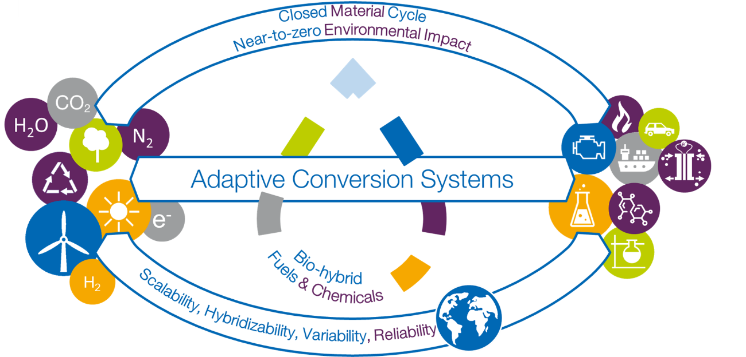
Figure 1: Vision of FSC 2.0 „The Fuel Science Center generates fundamental knowledge and novel scientific methods for the development of adaptive technical solutions to valorize renewable electricity and feedstocks into liquid energy carriers and chemicals in a systems approach”
MISSION
FSC has its roots in the CoE „Tailor-made Fuels from Biomass (TMFB)“ at RWTH Aachen (2, 3). A unique interdisciplinary collaboration was established between combustion engineering, chemical engineering, chemistry, and biology using the intricate relation between combustion properties in on-road propulsion systems and the molecular structure and composition of advanced bio-based fuels as common denominator. By strategic development of projects and structural measures, a fundamental understanding of „fuel design“ was successfully established for the first time. In the subsequent phase, FSC was able to establish the broader field of „fuel science“ internationally by overcoming disciplinary borders through composing the extended competencies of the network according to the time- and length-scale of the molecular, device, and systems level. Translational research teams were formed to foster collaboration and scientific exchange on specific research questions. While carbon-based fuels where still at the center of the research activities, their application in advanced engine technologies and their „bio-hybrid“ production based on biomass as well as CO₂ as alternative carbon sources could thus be envisaged. Expanding the research topics beyond the technosphere demonstrated the importance of adaptivity as important design criteria to cope with the dynamics and variations in energy and feedstock supply at the interface between the energetic and chemical sectors.
The successfully established concept of interdisciplinary Competence Areas (CAs) and their effective and dynamic interconnection now form the backbone of the fully integrated research framework in the next phase of FSC. All research activities and projects are fully allocated within Strategic Research Areas (SRAs) where they absorb and vice versa stimulate the disciplinary progress of the individual PIs, thus constantly augmenting the CAs. This structure has been devised to allow for adaptive response to the global developments at the interfaces of the energy, mobility, and chemistry sectors on basis of scientific and methodological excellence. With the specific infrastructure of the partner institutions and the scientific profiles of the involved PIs, FSC is ideally positioned to align the focal technology options for post-fossil molecular energy carriers and products. Continuing efforts will be devoted to fuel design for low-carbon and low-emission liquid energy carriers. Ammonia is now included as molecular energy carrier and thermal as well as electrical devices for recuperation of the chemical stored energy are being studied. The chemical value chain is addressed explicitly as major area of application for the novel synthetic pathways and catalytic processes. Analysis on a systems level is developed as integrative part to provide design criteria for sustainability.
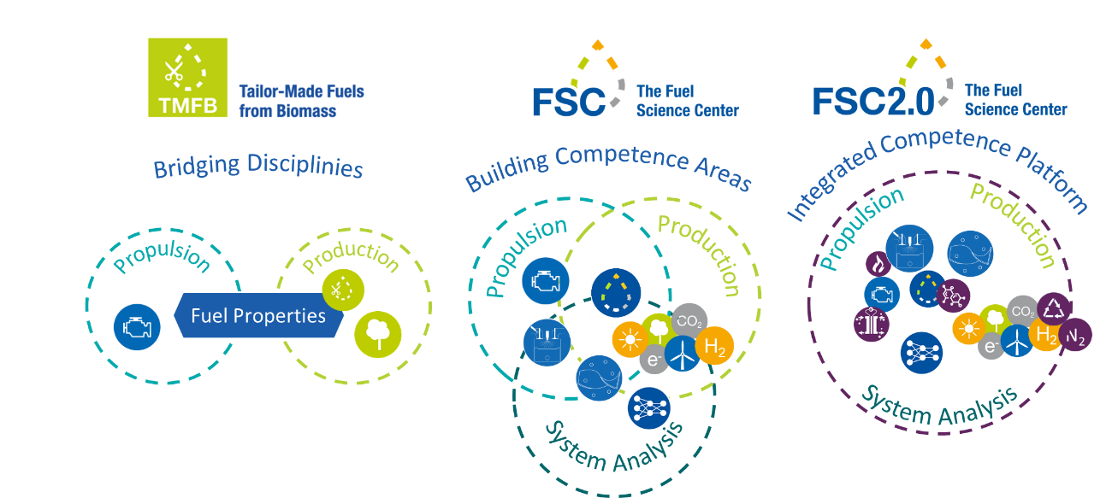
Figure 2: Evolution of FSC as Adaptive Scientific Platform

OBJECTIVES
The Strategic Research Areas for FSC will address the following key questions originating from the vision and mission outlined above:
- How does the molecular structure of carbon-based fuels impact on efficiency and emissions upon recuperation of the chemically stored energy in backward-compatible thermal or future electrical propulsion systems?
- How can engines and devices be designed to exploit ammonia as fuel most effectively?
- How can translational catalytic processes at the direct interface of energy and feedstocks be designed to cope with the dynamics and variations of their supply?
- How can chemical, biochemical, and electrochemical transformations for the manipulation of C-O and C-N bonds be interlinked to open concatenated synthetic pathways to fuels and chemicals?
- Systems approach ?

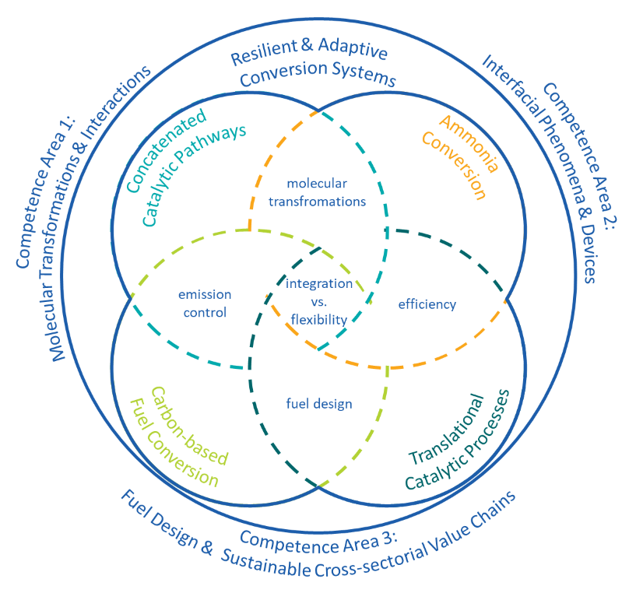
The SRAs are bridged via general design challenges that will be addressed in flexible working groups as the research progress develops. This includes for example the integration of production pathways and propulsion properties for the C-based fuel design, the fundamental mechanisms of electrochemical ammonia activation for energy or synthetic applications, the seemingly contradicting goals of integration for process chains and flexibility of individual process steps, and…??? The central platform for the discussion, analysis, and continuous adjustment of the overall research program in light of its mission and vision is provided in the „Systems Design Forum“.
Figure 3: Strategic Research Areas (SRAs)
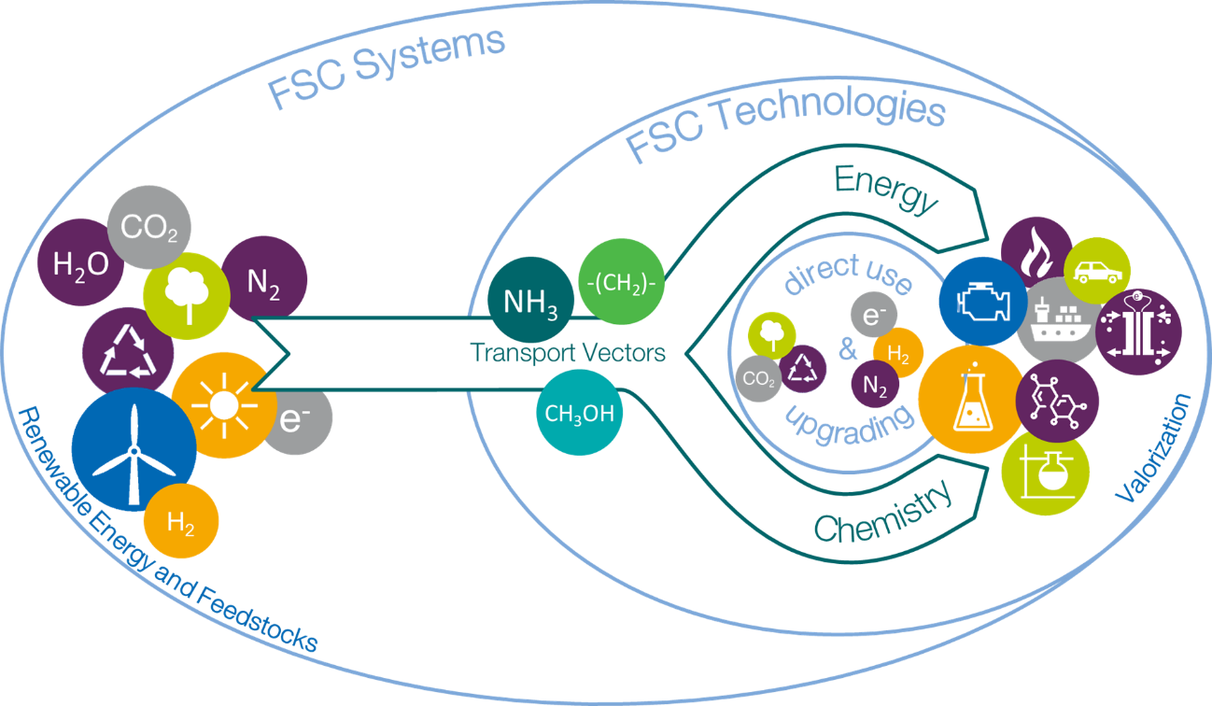

SCIENTIFIC APPROACH
CAs as the backbone
Short: Specific strengths of FSC, next major methodological developments,…
Research Program
SRAs descriptions => REIHENFOLGE FESTLEGEN!
The Systems Design Forum
Working groups; role and workflow of the forum
Literature
1. IEA - International Energy Agency. World Energy Outlook 2023.
2. Leitner, W., J. Klankermayer, S. Pischinger, H. Pitsch und K. Kohse-Höinghaus. Advanced Biofuels and Beyond: Chemistry Solutions for Propulsion and Production [online]. Angewandte Chemie (International ed. in English), 2017, 56(20), 5412-5452. Verfügbar unter: doi:10.1002/anie.201607257
3. Deutz, S., D. Bongartz, B. Heuser, A. Kätelhön, L. Schulze Langenhorst, A. Omari, M. Walters, J. Klankermayer, W. Leitner, A. Mitsos, S. Pischinger und A. Bardow. Cleaner production of cleaner fuels: wind-to-wheel – environmental assessment of CO 2 -based oxymethylene ether as a drop-in fuel [online]. Energy & Environmental Science, 2018, 11(2), 331-343. ISSN 1754-5692. Verfügbar unter: doi:10.1039/C7EE01657C

