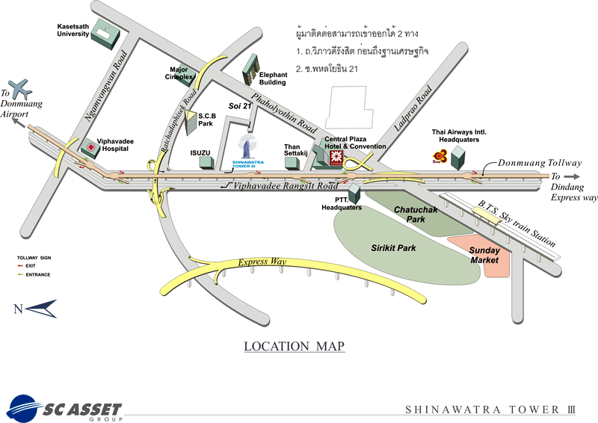
Shinawatra Tower III
Phahon Yothin Station (Subway)
Mo Chit Station (SkyTrain)

