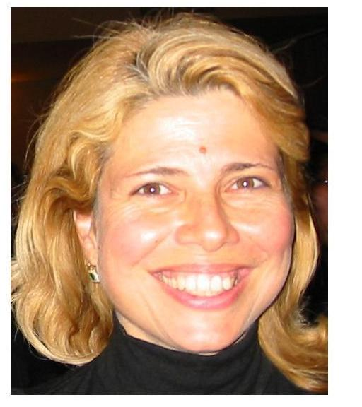

Marina Ruggieri graduated in Electronics Engineering in 1984 at the University of Roma. She was: with FACE-ITT and GTC-ITT (Roanoke, VA) in the High Frequency Division (1985-1986); Research and Teaching Assistant at the University of Roma Tor Vergata (RTV) (1986-1991); Associate Professor in Telecommunications at Univ. of L'Aquila (1991-1994) and at the University of RTV (1994-2000). Since November 2000 she is Full Professor in Telecommunications at the RTV (Faculty of Engineering), teaching DSP, Information and Coding. Since 2003 she directs a Master in “Advanced Satellite Communications and Navigation Systems” at RTV.
Since 1999 she has been appointed member of the Board of Governors of the IEEE AES Society (AESS). Since 2005 she has been also appointed Director for AESS Operations in Italy and Western Europe.
Her research mainly concerns space communications and navigation systems (in particular satellites) as well as mobile and multimedia networks.
She is the Principal Investigator of satellite scientific communications missions (DAVID, WAVE) of ASI, national research programs (CABIS) on CDMA integrated mobile systems and on satellite-HAP integrated networks for multimedia applications (SHINES), co-financed by MIUR. She co-ordinates RTV Unit in various European Projects: EU FP6 IP MAGNET (My personal Adaptive Global NET); EU ASIA LINK EAGER-NetWIC (Euro-Asian Network for Strengthening Graduate Education and Research in Wireless Communications); EU Network NEXWAY; GALILEO JU 1st Call: VERT (VEhicular Remote Tolling); and in the ASI program on V-band payloads (TRANSPONDERS).
She is Editor of the IEEE Transactions on AES for “Space Systems”. She has also been appointed Chair of the IEEE AES Space Systems Panel; since 2002, co-chair of Track 2 “Space Missions, Systems, and Architecture” of the IEEE/AIAA Aerospace Conference; member of the IEEE Judith A. Resnik Award Committee.
Since 2005 she has been appointed in the Technical Board of the Italian Institute for Navigation (IIN).
She was awarded the 1990 Piero Fanti International Prize and she had a nomination for the Harry M.Mimmo Award in 1996 and the Cristoforo Colombo Award in 2002.
She is author of about 220 papers, on international journals/transactions and proceedings of international conferences, book chapters and books.
She is an IEEE Senior Member (S'84-M'85-SM'94).

