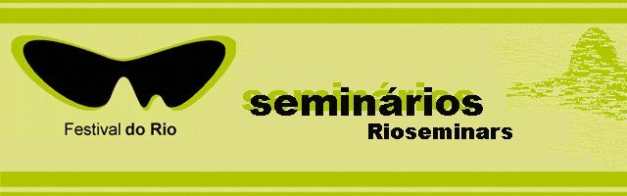

Festival do Rio is the top showcase in Brazil and the largest Latin American audiovisual event, bringing together, every year, professionals from all areas of the industry, especially from Latin America, Europe and the US. During these 15 day event, the festival gathers producers, sales agents, broadcasters and many other audiovisual professionals from all over the world.

Besides the screening of films, an important segment of the Festival do Rio is the Rio Screenings & Seminars, that is showcase and seminars. While rioseminars approaches important themes to the industry, besides bringing information about new trends and technologies, the rioscreenings will be dedicated to exhibitions of the most recent world productions, equipped with video and dvd cabins. This is a great opportunity to show and buy audiovisual products from Brazil and other countries.

From the 26th of September to the 5th of October, at the Le Meridién Hotel, the most important executives from different sections of the audiovisual industry (Cinema, TV, Home, Entertainment, Internet and Mobile Companies), will be meeting and joining the international seminars, lectures and workshops, where panelists and participants will analyse, discuss and create release strategies to foreign and brazilian movies, and will also be able to watch the most recent productions and take part on business meetings.

This year, the rioseminars will debate themes such as “the impact of new technologies at the audiovisual industry” – professionals from all over the world will participate on a series of panels that will present, analyze and clarify the new perspectives and technologies. The main purpose is to create a research about the new acquisitions, partnerships and co-production projections, such as the remarkable increase of the investments from the television networks and mobile content. It will also debate how product placement is getting positive results, and it will still include a prospect of the benefits and damages of piracy at the Digital Era.

confirmed speakers

Erica Motley – UIP
David Tames – Center of Digital Image in Arts - Boston University
Richard Guardian – Lightning Entertainment
Patrícia Primón – Nielsen
Griselda Fortunato – Fox Argentina
Saul Ladestro – Sony Pictures
Susan Wrubel – Paramount Classics
José Carlos Oliveira – Warner Bros Brasil
Bettina Sherick – Fox
Ezequiel Abramzon – Disney
Bruno Wainer – Lumiere Brasil
Yoichi Sakai – Gaga Communications
Kevin Brooks – Motorola Labs
Marco Aurélio Marcondes – Europa Filmes / MAM
Marcos Oliveira – Fox Film Brasil
Valmir Fernandes – Cinemark Brasil
Ben Smith – ICM Talents
Arturo Neto - UBV
Marilene Fernandes – Gr. Mídia RJ
Rodrigo Saturnino – Columbia
Ugo Sorrentino – Artfilms
César Silva – UIP
Adilson Xavier – ABP
Martha Cavalheiro - Fox

sponsorship

Municipal Government of Rio de Janeiro and Petrobras

cost

Company Package: R$500*

All days of the event: R$300
One day: R$100

*The Company Package allows total access to the festival´s seminars to 2 persons from the same company.

To subscribe please fill in the form attached and e-mail to :
seminarioinsc@festivaldorio.com.br
Subscribe now!

GREAT OPPORTUNITY:
Zarpar Tourism offers packages tours with special prices!
Check out the attachment and book our trip now!
For further information, contact by e-mail: zarpar@zarparturismo.com.br

