The next International Environmental Film Festival organised by the Ile de France Region takes place in Paris at the Cinema La Pagode, in Paris, from November 22 to 28, 2006.

Previous editions have shown feature films, documentaries and short films on subjects such as ecology, sustainable development, urbanism art, and the evolution of the world.
The following films have premiered at our festival, Darwin’s Nightmare, Heisei tanuki gassen pompoko, Ils ne mouraient pas tous mais tous étaient frappés, Lost in Translation, Sauf le respect que je vous dois, Sisters In Law, Work Hard, Play Hard, Arbres, Microcosmos, Terres et cendres, Winged Migration…

Screenings give producers, directors and actors, the opportunity to discuss the film with the public.

The jury members come from all kinds of profession, artists as well as journalists and people concerned by the environment (Allain Bougrain-Dubourg, Jacques Perrin, Jean-Michel Jarre, Tom Novembre, Laurence Côte, Humbert Balsan…). The president of this year’s festival is the photographer Yann Arthus-Bertrand.

The 2005 Festival opened with the screening of Mongolian Ping Pong.
7 000 spectators came to discover a selection of 52 films, in and out of competition, and to take part in several debates and Q&As.

Allain Bougrain-Dubourg, president of the jury, and the members of the jury awarded the following prizes :

- The First Prize (8 000 euros) and the Fiction Prize (4 000 euros) went toy Kekexili, Mountain Patrol, a feature film from China by Lu Chuan.
- The Documentary Prize (4 000 euros) went to Between Midnight and the roosters’s crow from Canada by Nadja Drost.
- The Jury Award (4 000 euros) went to Plagues and Pleasures on the Salton Sea, a documentary from the USA by Chris Metzler & Jeff Springer.

A Jury of Students and Apprentices from the region gave its award (4 000 Euros) to Raging Blues, a documentary by Vincent Parranaud and Lyonnel Mathieu.

The next edition of the festival will continue to embrace the great variety of environmental films, through screenings, debates and discussions.

2006 is the year of the “Francophonie” in France and the Festival will celebrate it by inviting the Fespaco Festival, a festival that has worked for many years to present films from the Francophone community.

To facilitate a rich program of films, we are looking for documentaries, feature films and short films to participate in the festival.

We encourage you to submit your films and we look forward to working with you in the near future.

Best Regards.
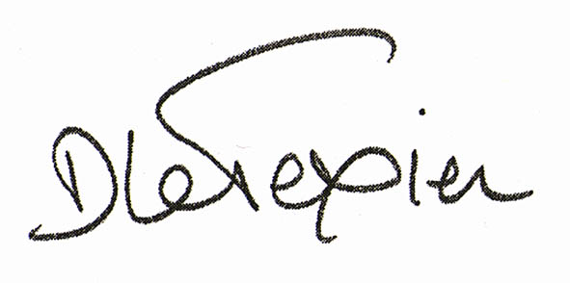
Dominique Le Texier
Déléguée Générale

Mail : contact@festivalenvironnement.com / Tel : + 33 1 53 85 67 94
Site : www.festivalenvironnement.com

