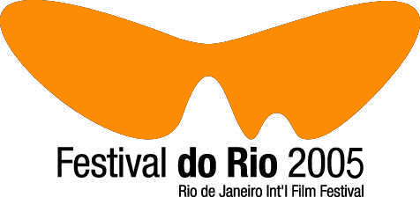

International

5 days, 4 nights
• Round trip air fair (Varig)
• Accommodation/breakfast
• Passport of cinema tickets for the Festival do Rio (1 ticket per day of staying)
• Exclusive handbag from the designer Gilson Martins
• Airport transfer / Hotel / Airport
• Travel health insurance.

Starting at:
Frankfurt |  | $1.297,00
Hong Kong |  | $3.075,00
Seul |  | $2.897,00
London |  | $1.409,00
Los Angeles |  | $1.285,00
Mexico City |  | $1.296,00
Miami |  | $1.177,00
New York |  | $1.205,00
Paris |  | $1.017,00
Pequim |  | $2.897,00
Rome |  | $1.326,00
Sidney |  | $2.051,00
Madrid |  | $1.303,00
Tokio |  | $1.874,00
Washington |  | $1.305,00

* Taxes and air charges are not included . Prices in dollars per person for a double room in the Hotel Plaza Copacabana (http://www.windsorhoteis.com.br/en-us/pl_loca.asp). Prices and conditions can change without previous notice.

International

8 days and 7 nights.
• Round trip air fair (Varig)
• Accommodation/breakfast
• Passport of cinema tickets for the Festival do Rio (1 ticket per day of staying)
• Exclusive handbag from the designer Gilson Martins
• Airport transfer / Hotel / Airport
• Travel health insurance.

Starting at:
Frankfurt |  | $1.518,00
Hong Kong |  | $3.296,00
Korea (Sul) |  | $3.118,00
Londres |  | $1.630,00
Los Angeles |  | $1.506,00
Mexico |  | $1.517,00
Miami |  | $1.398,00
New York |  | $1.426,00
Paris |  | $1.238,00
Pequim |  | $3.118,00
Roma |  | $1.547,00
Sidney |  | $2.272,00
Espanha |  | $1.524,00
Tóquio |  | $2.095,00
Washington |  | $1.526,00

* Taxes and air charges are not included . Prices in dollars per person for a double room in the Hotel Plaza Copacabana (http://www.windsorhoteis.com.br/en-us/pl_loca.asp). Prices and conditions can change without previous notice.

