JUNGLE PARTY
INFORMATION
Muriel BAUMGARTEN – EVENTALYS – Cannes
Phone : +33(0)620021166 – Fax : +33(0)493465422 - email : eventalys@free.fr
RCS Cannes – Siret 449032119
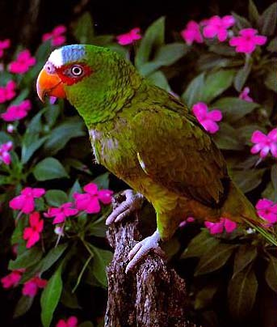
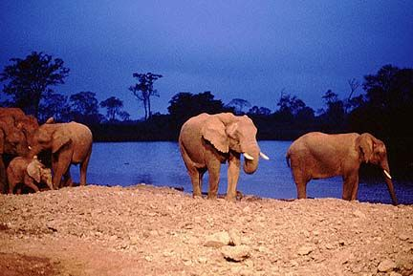
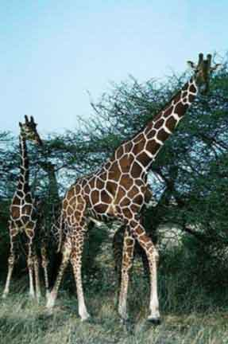
Option : We can re-create
An Alive Jungle Of Wild Animals
( tiger, snakes, monkeys, parrots, black panther)
15.000 euros

DINNING COCKTAIL

Greedy Bouchee
Aumônière presentation of pancakes with Foie Gras - Celery Roquefort cheese - Heart of chicory- Salmon cubes - Cherry Tomatoes - Tourteau crab flesh - Quail Eggs & salmon roes

Luxury Canapes
Smoked salmon with aneth-smoked trout-Duck magret- Scramble eggs - poutargue - Saddle of rabbit - Olive paste tapenade -Parma Tangerine-Cherry tomatoes & mozzarella cheese
Red mullet fillet in Escabèche - Quail eggs with tomato and basil

Brioche Bun

Tarama cream and Crab flesh

Surprising Bread
Raw ham - Liver mousse - Cheese and nut

Provencal Sushi
Prawn - Red mullet and duck – Olive oil and lemon sauce

Cassolette presentation
Pickled vegetables & red mullet filet–Celery rémoulade with salmon roes – Taboulé with shellfish, Lotte frog fish in Tahitian

Greedy Stick
Melon mint - Ham Goat cheese & Chives, grape raisin & duck
Chicken liver sweet & Sour

Verrine Presentation of
Gaspacho Spanish cold soup, Asparagus Cream

Dry-Braisedes Duck Foie Gras
Farmhouse bread & Mini Kebab of Duck with honey

Mini Bouillabaisse

Fish Soup - Service in bowl
Mini Barbecue –
Beef kebabs, Tunny with lemon

Tray of Cheese Selection & mini bread selection
Desserts
Petits Fours- Fruits Tartlets- Opéra- Salambo- Éclair, Savarin, Meringue- Hedgehog Presentation of fruits Stick- Mini Chocolate mousses
OPEN BAR – Champagne- Provence Wines (blanc, Rosé, Rouge) – Orange juices - Coca cola- Tonics – Minéral water -

All these courses can be modified upon special requests

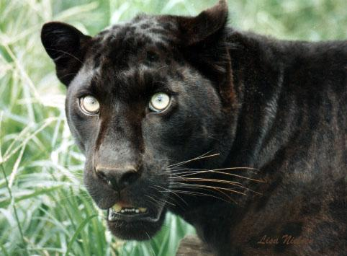
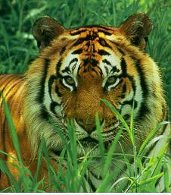
On the private beach MIRAMAR , let your clients enjoy an exotic atmosphere and a typical animation from AFRICA

PRICE PER PERSON – 380 euros
Including 2 hours open bar, buffet, drinks, animation

