THE LOVE BOAT PARTY

INFORMATION
EVENTALYS – Muriel Baumgarten-19, avenue du Grand Jas – 06400 Cannes- France
Tél:+33(0)620021166 – email : eventalys@free.fr

Rcs Cannes – Siret 449032119

PRICE PER PERSON - 370 euros
Including Open bar, buffet , trio jazz band and DJ animation

MENU OF THE DELPHINE PARTY

First plate buffet
Palm tree presentation of shelled prawn ( and sauces) /Pantin duck form duck fillets with olives /Chicken liver salad with caper/ Rice salad with shellfish /Croustade pie with sweet potatoes /Lotte frog-fish salad with saffron
French bean salad with tomatoes /Tourteau crab mousse
Salad Of the islands with cream sauce and chives

Hot Buffet
Curried lamb ‘sauté’- white rice – zucchini gratin
(rougails mixed garlic , tomatoes and zucchini)
OR

Curried lotte frog-fish with coconut milk
OR
Calamar with creamy sauce
OR
Scallop with citronella and pineapple

Sweet buffet
Exotic fruits salad/rocher of coconut/sweet entremets with mango & pawpaw /selection of sherbet bowls/strawberries/Petits fours

Open Bar
Beer, provence wines ( rouge, white, rosé), fruits juices, sodas, waters, coffees

ALL THESE COURSES CAN BE MODIFIED UPON SPECIAL REQUEST
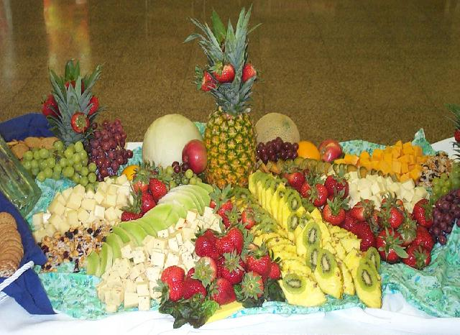
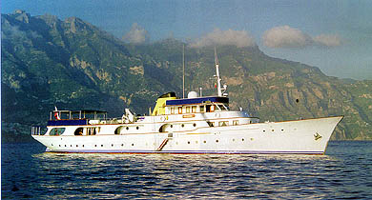
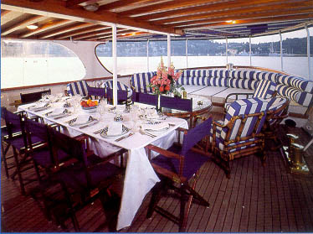
The splendid yacht Fulmara will welcome your guests for a glamorous moment on board
