Présidente
Isabelle Adjani

Paris ,December 6 th 2004

By email :

The Festival du Film de Paris was created in 1986 by Louisa Maurin and its 20th edition will take place from Monday March 28 to Monday April 4, 2005. It will take place in Paris at the Cinema Gaumont Marignan on the Champs Elysées and, for the first time, in a dozen cities in the Region Ile-de-France, around Paris.

Our ambition is to introduce films from all nationalities, cultures and genres to a large public of film fans, as well as journalists and professionals, many of them distributors, and to reveal the talents of tomorrow.

The Competitions

The OFFICIAL COMPETITION selects 7 first and second feature films, not yet released in France. The Golden Arc will be awarded by an international jury.

The PRESS AWARD will be given out by a jury of journalists to one of 7 international films, not yet released in France, and without a distribution. This award aims to help distribution in France and a marketing campaign is offered.

The PUBLIC'S CHOICE AWARD allows the general public to vote for their favorite film among 7 first or second French films, produced within the year.

The "FRANCOPHONIE" AWARD will be given to one of 7 films from the French-speaking world.

The Other Sections

To complement these competitive sections, the section CINEMA D'AUJOURD'HUI will present some 20 international feature films and documentaries .

FRENCH CINEMA will not be forgotten with 6 directors, actors and producers presenting three of their films over one day.

To celebrate cinema, the Festival du Film de Paris invites films from all over the world. As Programme Director, I'm looking forward to working with you and developing a long lasting relationship to bring your best and most innovative films, with an international potential, to Paris. These films would also strongly benefit from being screened in Paris and in cities around Paris, during our festival.

We look forward to screening your films.

Best regards.
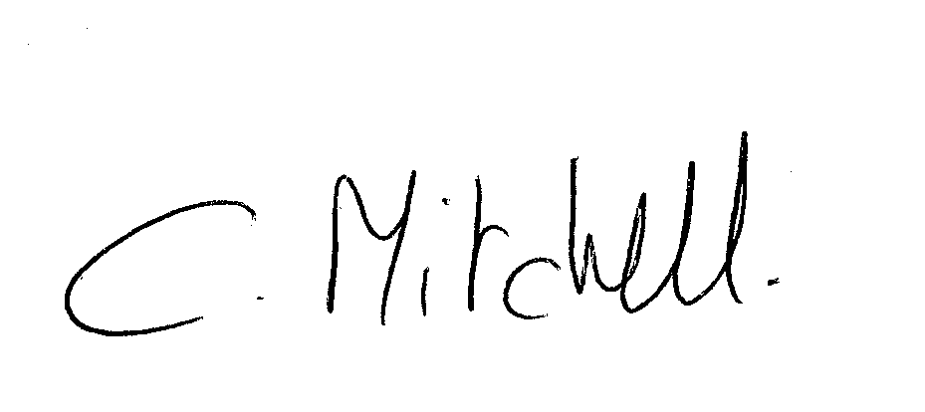
Caroline Mitchell
Program Director
programmation@regiefestivals.fr - + 33 1 58 05 25 50

Included : Entry form / Summary of Rules and Regulations

SUMMARY OF RULES AND REGULATIONS

The deadline for all applications is March 1st, 2005. The entry form must be accompanied by a VHS tape or DVD of the submitted film (in its original language, subtitled in French or in English), with a synopsis and a biography of the director.

All prints of the selected films must reach the Festival, on March 20, 2005 (at the expense of the producer or distributor).

Accepted films for the Festival can only be exhibited in 35 mm format, in their original version, with French subtitles.

The Festival invites one guest per film in the competitive sections for three days (transportation and accommodation).

20ème FESTIVAL DE PARIS ILE-DE-FRANCE

28 Mars – 4 Avril 2005 / March 28 - April 4, 2005

BULLETIN D’INSCRIPTION / ENTRY FORM
Inscription avant le 15 février 2005/ Submission before February 15, 2054

TITRE ORIGINAL / Original title : ……………………………………………………………..

TITRE FRANÇAIS / French title :……………………………………………………………….

TITRE EN ANGLAIS / English title :……………………………………………………………

Date d’achèvement du film / Date film completed :…… ………… …………………………….

Réalisateur /
Film director :……………………………………………………………………….

Nationalité / Nationality :………………………………………………………………………….

Pays de production / Country of production :………… …………………………………………

INFORMATIONS TECHNIQUES / Technical information

Format du film / Screening format : 35mm □

Son / Sound Mono □ Dolby SR □ Autre/Other □

Dolby □ THX □

Format projection / Screen ratio : 1.33 □ 1.66 □
1.85 □ Cinémascope □

Cadence / Speed : 24 images / frames □ 25 images / frames □

Couleur / Color □ Noir et Blanc / Black & White □

Durée du film / Running time : ………………………………………..

Nombre de bobines / Number of reels : ……………………………….

Existe-t-il une cassette disponible ? / Is there any videotape available ?
Oui / Yes □ Non / No □

Format : VHS □ U-MATIC □
Standard : SECAM □ PAL □ NTSC □

Version de la cassette / version of the tape

□ Version originale / Original version
□ Sous-titrée en anglais / English subtitles
□ Sous-titrée en français / French subtitles
□ Version française / French language

La copie est-elle déjà sous titrée ? Is the print already subtitled ?

□ en français / in French   □ en anglais / in English
 □ non sous-titrée / not subtitled  □ autre langage / other language ……………………..

Catégorie / Category

□ Fiction / Fiction □ Documentaire / documentary
 □ Long métrage / Feature film □ Court métrage / short film

Valeur de la copie en Euros (en vue de l’assurance du film)
Value of the print in euros (for insurance purposes)

……………………………………………………………………………………………………………………

Adresse où doit être réexpédiée la copie après le Festival
Address where the print should be returned after the festival

………………………………………………………………………………………………………………………………………………………………………………………………………………………………………………………………………………………………………………………………………………………………………………

Production : nom, adresse, téléphone, numéro de fax, adresse email

Production company : full name, address, telephone number, fax number, email address
………………………………………………………………………………………………………………………………………………………………………………………………………………………………………………………………………………………………………………………………………………………………………………

Distribution : nom, adresse, téléphone, numéro de fax, adresse email

Distribution company : full name, address, telephone number, fax number, email address
………………………………………………………………………………………………………………………………………………………………………………………………………………………………………………………………………………………………………………………………………………………………………………

Représentant en France : nom, adresse, téléphone, numéro de fax, adresse email
Representative in France : full name, address, telephone number, fax number, email address
……………………………………………………………………………………………………………………………………………………………………………………………………………………………………………………………………………………………………………………………………………………………………………………………………………………………………………………………………………………………………………………………………………………………………………………………………………………………………

Existe-t-il un extrait ou une bande annonce pour un passage à la télévision (norme Betacam) ?
Is there any video clip/trailer (not NTSC) available for a television screening ?

□ Oui / Yes □ Non / No

Le film a t-il été distribué dans son pays d’origine ou ailleurs ?

Has the film been distributed in its country of origin or elsewhere ?

□ Oui / Yes □ Non / No
Quand ? / When ?
……………………………………………………………………………………………………………………

Participation à des festivals - prix, mentions / Festival participation – prices, distinctions
…………………………………………………………………………………………………………………
……………………………………………………………………………………………………………………
……………………………………………………………………………………………………………………

Merci de joindre à ce bulletin la documentation suivante :
Please include with this entry form the following documentation :

□ Synopsis (5 lignes) / synopsis (5 lines)
□ Générique complet / film credits
□ Biofilmographie du réalisateur / director’s biofilmography

Engagement de participation / participation agreement

La société de production du film représentée par / The production company of the film represented by :

…………………………………………………………………………………………………………………………

accepte de prêter sa copie au Festival du Film de Paris /accepts to lend his/her print to the Paris Film Festival

J’ai pris connaissance du règlement du Festival du Film de Paris et en accepte la teneur,
I have read and agree with the regulations of the Paris Film Festival

Nom / Name : ………………………………………………

Fonction / Position :………………………………………..

Date : ……………………….

Signature :

