CANNES FILM FESTIVAL 2002
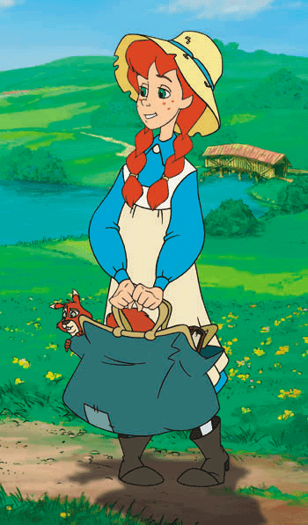
ANNE OF GREEN GABLES: The Animated Movie www.annetoon.com
A lavish animated feature, prequel to the world famous novel Anne of Green Gables, a delightful fantasy for kids and family. Following the adventures of the precocious orphan – Anne Shirley who captures the hearts and minds of the citizens of Avonlea.

SCREENINGS: Wednesday 15 May 2002 at 16:00 – Riviera 8

Thursday 16 May 2002 at 16:00 – Riviera 6

Thursday 23 May 2002 at 9:30 – Palais V
Please RSVP: tbelson@sullivan-ent.co.uk

We will be located on the British Pavilion

We can be reached at Hotel de Provence
9, rue Moliere – 06400 Cannes
Tel: + 33 (0) 4 93 38 44 35
Fax: + 33 (0) 4 93 39 63 14
Mobile: + 44 (0) 7 818 436 837

OTHER SULLIVAN’S PRODUCTIONS: --------------------------------------------------------------------

THE PIANO MAN’S DAUGHTER – www.sullivan-ent.com/PMD.html

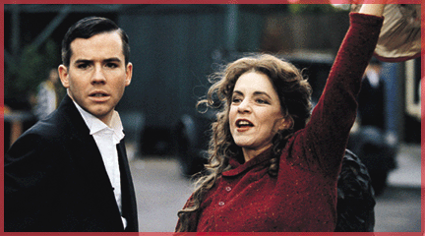
Charlie Kilworth (Christian Campbell) is a charismatic musician who leads a promiscuous life-playing piano for a swing band in the 1930's. When he finds himself falling in love, he starts to examine his inability to commit, a trait he traces back to his bohemian mother, Lily (Stockard Channing). In coming to terms with his psychological scars, he exposes the mysterious secrets of three generations of Irish forbearers.

Collection of 5 beautifully crafted Christmas Movies including HAPPY CHIRSTMAS MISS KING, THE WILD PONY, CHRISTMAS IN NEW BEDFORD…
And much more!

