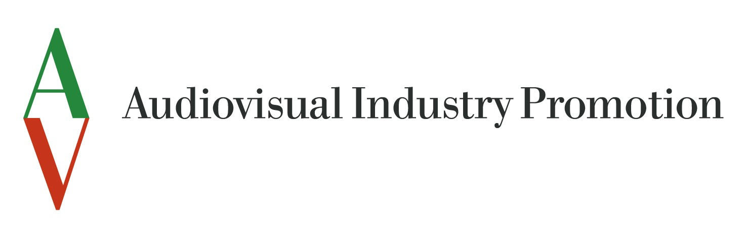


Audiovisual Industry Promotion, the new body in charge for the foreign promotion of the Italian Film Industry and the organization of international film and audiovisual markets like the most celebrated Mifed in Milan, has officially been founded on December 10 in Milan by Pupi Avati (chairman of Cinecittà Holding) and Piergiacomo Ferrari (CEO for Fiera Milano Spa).

Partners of the Company are Fiera Milano Spa (Milan Exhibition Centre hosting 70 exhibitions that annually attracts 4,5 million visitors, listed in the Milan Stock Exchange) and Cinecittà Hoding (the Government body of the Italian cinema), respectively with 50% and 50% stake in the company.

The Company will be managed with the role of Chief Executive Officer by Carlo Bassi already known in the film industry as Mifed’s Market Director. Giovanni Galoppi (member of the Board of Cinecittà Holding) has been nominated President of the company.

The new company will consist in two major operating divisions respectively responsible for the activities of Foreign Italian film industry promotion (under the name of Filmitalia) and the organization of Mifed market.

