EXPRESSION OF INTEREST

Network of Excellence

BIOMATERIALS and MEDICAL TECHNOLOGIES

Lund / S
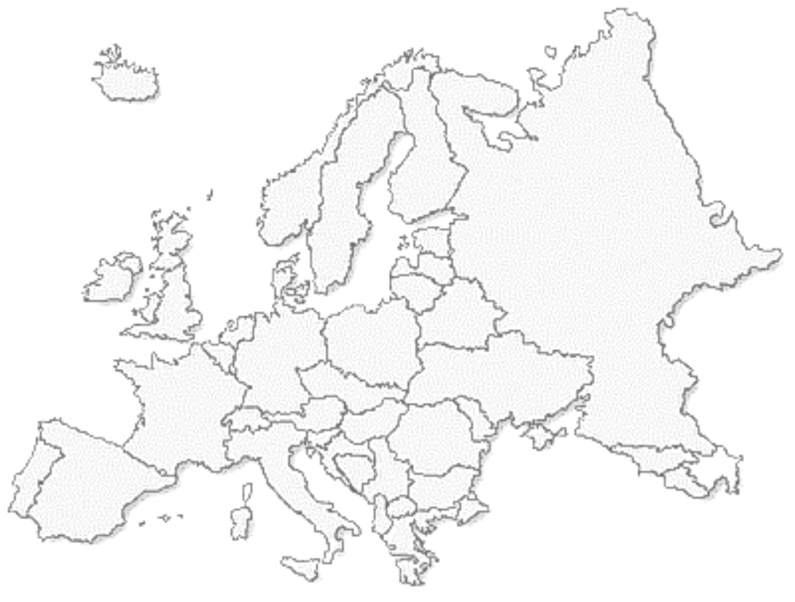

BIOMATEC

Aachen / D

Pisa / I

CORE GROUP
WG Biomaterials NRW e.V. | / Germany
BMC - University Hospital Lund | / Sweden
CNR - Institute of Clinical Physiology Pisa | / Italy
LGC - Laboratory of Government Chemist Teddington | / United Kindom
MCBR – University of Maastricht | / The Netherlands
Dept. of Biomaterials (ZIBMT) University of Ulm | / Germany
24 universities or research institutes, 10 Companies (4 SME´s) and 6 organisations
from 10 member states and 4 associated states

Prepared by Richter@pat.rwth-aachen.de | 29.07.2026, 07:18

1. NEED and RELEVANCE
Needs: The sector “biomaterials and biotechnologies” is the largest branch of economy with the highest growth rate due to the increase in life expectancy of humans in industrial countries. Genomics and Proteomics as well as the microsystem technique and nanotechnology are the research fields leading into the future. They are unfortunately not satisfyingly linked to each other at the moment. The basic knowledge of above mentioned research fields are wisely linked. Synergy effects and new ideas for solutions in diagnosis, therapy and pre-vention, for example biohybrid organs (e.g. artificial liver), neuroprostheses (e.g. retina implant) and new medical products (e.g. antibacterially equipped catheters) will appear. Chemistry, material sciences, molecular biology, clinical medicine are to be integrated in a way that can coordinate the problems of medicine and solve them with new ideas and developments. Members of the core group and many other partners of the NoE have several years of experience in interdisciplinary projects, yet the new form of an institutionalised cooperation (NoE) is generally seen as a source of greater efficiency. Knowledge-based multifunctional materials are urgently necessary for both passive and especially active implants as well as medical products. Scaffolds for example are to be designed in a way which links the implant tightly with the tissue in a 3D-structure (hernia mesh with covalently linked proteins respectively peptides of the extracellular matrices (ECM), vascular grafts with autologous endothelial cells). The development of medical products with intelligent surfaces can serve a speedy integration of the implant into the surrounding tissue (coating with ECM-proteins and growth-factors), or serve the prevention of infections through the implant (antibacterial equipment of catheters). Intelligent polymers with a memory for forms, e.g. as stent for coronary arteries, tubes etc., offer new possibilities for the tissue engineering (minimally invasive implantation). The ideas for possibilities of implementation of the new memo-ry-polymers, e.g. as medical disposals in orthopaedics or as dental material with adjustable drug release, are supported via the interdisciplinary cooperation. Further interesting alternative to the actually used materials for vitreous body replacements, intervertebral discs or wound-coverings can be the use of swelling hydrogels.
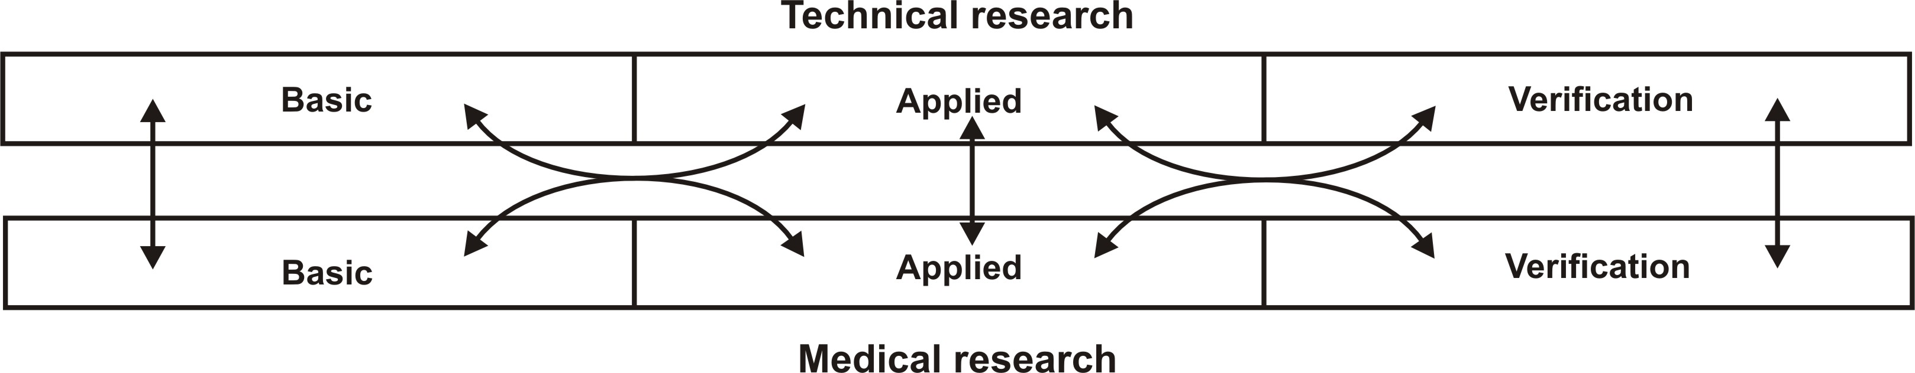

Relevance: The NoE “Biomaterials and Medical Technologies” (BMT) is directly concerned with the main focus of “Genomics and Proteomics”, as well as “Nanotechnology” and “knowledge-based multi-functional materials”. Research in sector “biomaterials and biotechnologies” need to be multidisciplinary and should be more concentrated and strategically guided. In general the NoE will organise closer collaboration between scientific, technical and medical research. Genomics and Proteomics and autologous primary cells / stem cells are work fields of Soft Tissue Engineering, e.g. biohybrid systems, reabsorbable wound-coverings (e.g. collagen structures with epithelial cells), neurological implants (technical nerve-contact as a scaffold to the epineurium).

2. EXELLENCE
Leading academic and industry: The group will consist of sophisticated scientists directly involved in re-search, foundations representing the patients to who the research will be of relevance and SME´s involved in project and direct production of actual devices. Partners participating in the EoI working on named themes have the necessary “know-how” and are therefore predestinated for the NoE BMT. European strategic alliances are necessary to maintain the european competive edge of the sector Biomaterials and Medical technologies. The general technological upward trends (biodegradables, surface modification, hybrid materials) have to be rein-forced.
Tab. 1: Core group, research- and industral partners as well as organisations
 | Organisation | Country |  | Chief  Scientist |  | Area of Excellence |  | Role in  Project
CoRE GROUP
1 | WG Biomaterials NRW |  | Germany |  | H.A. Richter |  | Biocompatibility, Tissue Engineering |  | Coregroup
2 | BMC Lund |  | Sweden |  | Heinegard |  | Molecular biology |  | Coregroup
3 | CNR Pisa |  | Italy |  | Donato |  | Haemocompatibility, cardiology |  | Coregroup
4 | LGC Teddington |  | UK |  | Braybrook |  | Biomaterials, Training |  | Coregroup
5 | Uni Maastricht |  | The Netherlands |  | Koole |  | Polymer development |  | Partner
6 | Uni Ulm ZIBMT |  | Germany |  | Franke |  | Biomaterials, Tissue Engineering |  | Coregroup

RESEARCH Partners
7 | MIT Boston |  | USA |  | R. Langer |  | Consultants |  | Consult.
8 | Uni Essen |  | Germany |  | Bingmann/Löer |  | Bone, LSM, chemotaxis |  | Partner
9 | Uni Brussels |  | Belgium |  | Kruse |  | Chemistry, smart gels |  | Partner
10 | Uni Marburg |  | Germany |  | Eckhorn |  | Physiology, neuro implants |  | Partner
11 | Uni de Vigo |  | Spain |  | Mrs. Fong |  | Laser coating, HT implants |  | Partner
12 | Uni Bologna |  | Italy |  | Giardino |  | Expert. surgery, biocompatibility |  | Partner
13 | Uni of Sheffield |  | UK |  | Hatton |  | Cartilage, glass-ceramic |  | Partner
14 | CAESAR Bonn |  | Germany |  | Hoffmann |  | Surface research, prototyping |  | Partner
15 | Uni Thessaloniki |  | Greece |  | Kiparissides |  | Polymer development |  | Partner
16 | Uni Köln |  | Germany |  | Kirchhoff |  | Retina implant, IODS, ophthalmology |  | Partner
17 | Uni Mainz |  | Germany |  | Kirkpatrick |  | Cell culture, Histology |  | Partner
18 | Uni Lodz |  | PL |  | Rosiak |  | Biomaterials, Radiology |  | Coregroup
19 | Uni-Paris 13 |  | France |  | Mr. Migonney |  | Chemistry, bioactive copolymers |  | Partner
20 | RWTH Aachen |  | Germany |  | Mokwa/Wallent. |  | Biomat., microsystem impl., biomech. |  | Partner
21 | Uni Pisa |  | Italy |  | Di Rossi |  | Electrical & medical technology |  | Partner
22 | Uni Bern |  | Switzerland |  | Weiss |  | Neuropathology, biocompatibility |  | Partner
23 | DTI Industry |  | Denmark |  | Theilgaard |  | Analysis, development of polymers |  | Partner
24 | Uni Tübingen |  | Germany |  | Zrenner |  | Ophthalmology |  | Partner
25 | NAS Kiev |  | Ukraine |  | Galatenko |  | Bioengineering, TE, cell culture |  | Partner
INDUSTRIAL Partners
28 | MTZ Aachen |  | Germany |  | Mrs.Müller |  | Damage research |  | Partner
29 | Johnson+Johnson |  | USA |  | Bone |  | Orthopaedics, cardiology, skin care |  | Partner
30 | EURESIS Aachen |  | Germany |  | Briolant |  | Management, consulting |  | Partner
31 | CREAVIS Marl |  | Germany |  | Heinrich |  | Expertise, research & innovation |  | Partner
32 | *Acri.Tec München |  | Germany |  | Mrs. Kreiner |  | Biomaterials, Ophthalmology |  | Partner
33 | MEDTRONIC |  | The Netherland |  | Larik |  | Medical products |  | Partner
34 | MnemoScience |  | Germany |  | Lendlein |  | Memory polymers, medical products |  | Partner
35 | VYGON Aachen |  | France |  | Loevenich |  | Manufacturing of act. med. device |  | Partner
36 | SIEGEL Würzburg |  | Germany |  | Siegel |  | Surface modification, PDMS |  | Partner
37 | FAB |  | Italy |  | Mrs. Pavesio |  | Artificial skin |  | Partner
ORGANISATIONS
38 | BioCon Valley |  | Germany |  | Cuypers |  | Consulting, SME |  | Partner
39 | DGBM Mainz |  | Germany |  | Kirkpatrick |  | Exchange of ideas, biomaterials |  | Partner
40 | GKSS Geesthacht |  | Germany |  | v. Sengbusch |  | Polymer research & development |  | Partner
41 | FGW Remscheid |  | Germany |  | Stehr |  | Exchange of ideas, hard tissue |  | Partner
42 | Europ. Soc. Biomat. |  | UK |  | Revell |  | Bone, scaffold, tissue engineering |  | Partner
43 | BIOBRIDGE |  | UK |  | Lloyd-Evans |  | Consulting, training, lecture |  | Partner
The core group received LoI of all the participating partners. We are happy to provide the surveyor with those LoI’s.
Critical Mass of resources: The interdisciplinary consortium of the NoE „BIOMATEC“ consisting of 24 university partners from 10 member- and 4 associated states as well as 6 organizations and 10 companies (4 SME’s) represents the leading experts in the specific fields of material research, molecular biology, ortho-paedics, material stability and tissue compatibility. Within the core group, there are at least six scientists of five member states represented (Tab 1).
The coordinator, namely the RWTH-Aachen, represents the workgroup “Biomaterials NRW” e.V.. He has both the know-how of biomaterial research as well as the experience and the infrastructure to organise and coordinate such a complex task. The activities in the field of Biomaterials and Medical Technologies of the RWTH Aachen are concentrate in 3 Centres of execellence, namely IZKF BIOMAT (clinical research), AKM (medical techno-logy) and bwA (polymer research and development). The members of the core group are scientifically qualified in the expertise of material technology, surface modifications, tissue engineering as well as the biology and the medicine of tissue and cells. Partners of other universities, research institutes, professional associations and patient organizations assist them. The SME’s contribution guarantees a high degree of practice with regard to prototyping over the production to the commercialization.
The chief scientists have the expertise in training and in lectures already due to their office. The concerned uni-versities and organizations of the network have the necessary expertise in spreading of excellence (dissemination of the knowledge, exploitation of results, etc.). Foundations, unions and organizations were chosen according to their expertise in their specific field.
The still missing expertise is hired by the cooperation of the NoE, for example for the planned NoE „Bioma-terials and Medical Technologies” or the Integrated Projects “Minimal Invasive Surgery: Tools and Moderate Imaging”. At this point, the core group expresses its willingness to permanently cooperate with the groups that have delivered an EoI in the specific field, or to form a mutual NoE.

Fig. 1: Organization structure of the NoE “Biomaterials and Medical Technologies”
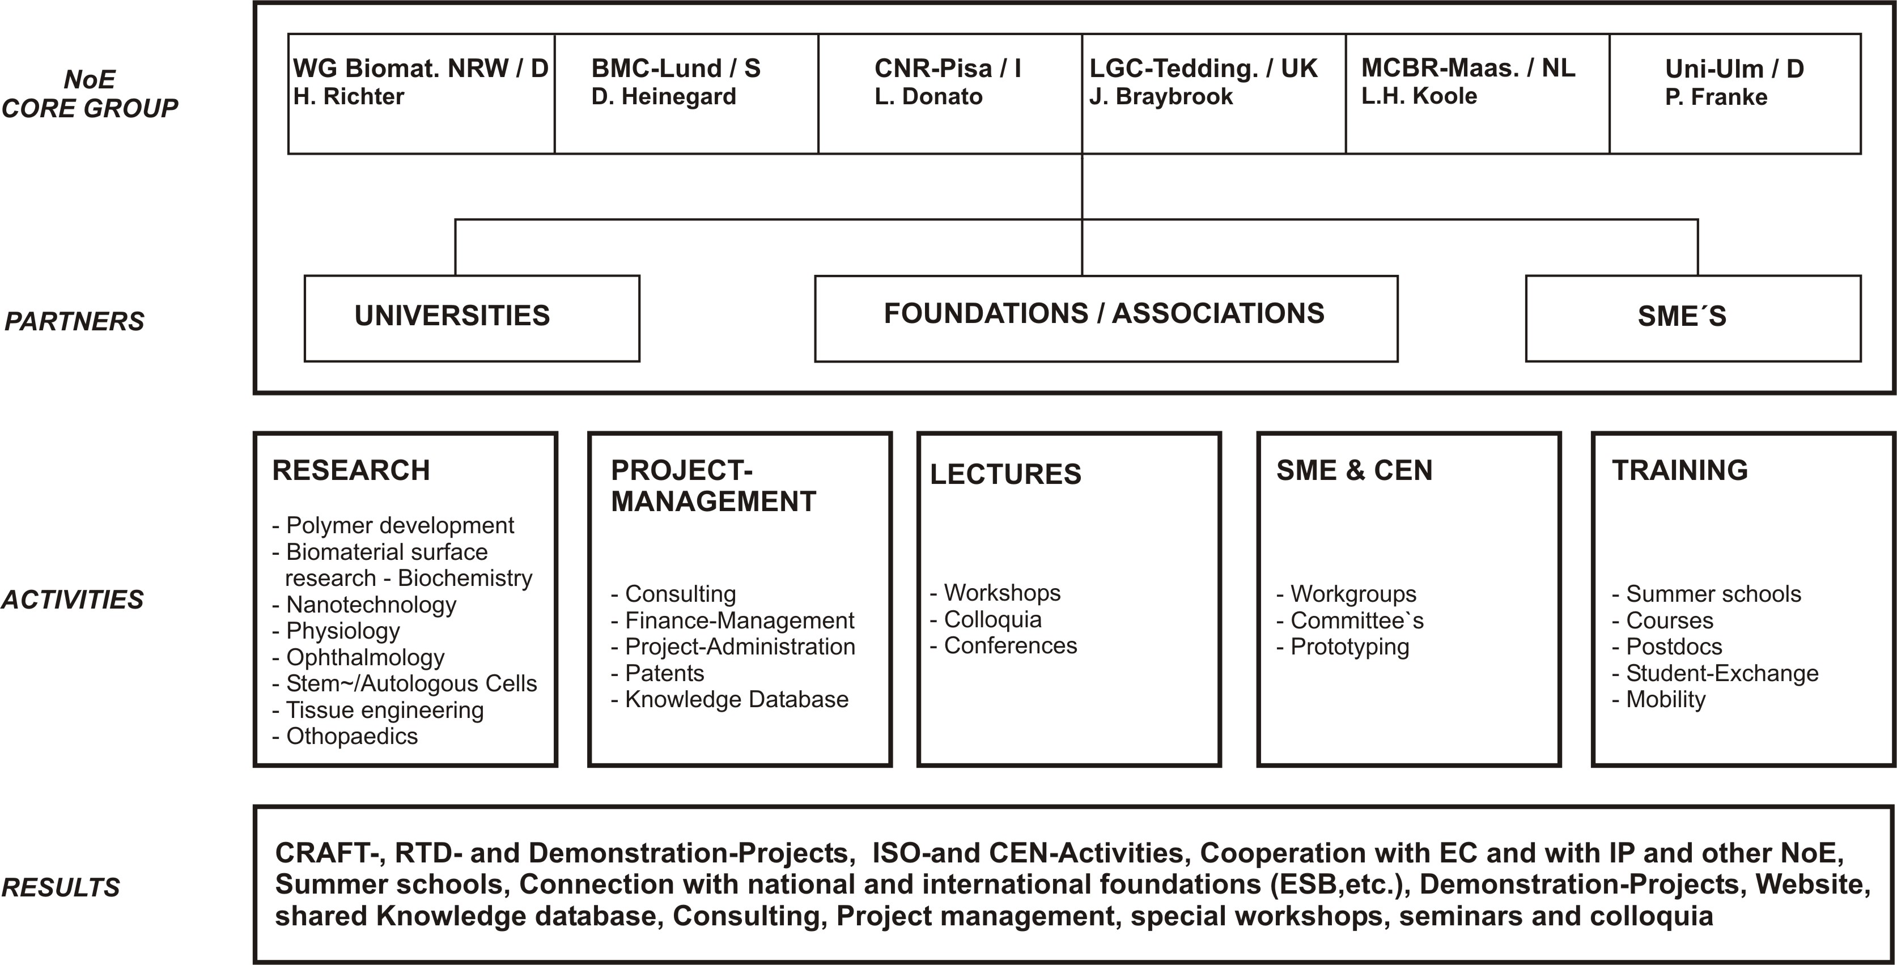

3. OBJECTIVES
Research Activities: The research activities to develop passiv and active implants include the tasks: research and development of biomaterials and nanotechnological components, in vitro-tests, in vivo-tests and clinical trials. Research and development of biomaterials, which shall be usefull for long time stable implants and im-plants with intelligent functionality, is concentrated to the optimization of physical, chemical and biological material properties. The properties of nanotechnological implants need to be adapted to requirements of biolo-gical environments (e.g. electrical integrity). Parallel to biomaterial surface research (biochemical modifica-tions), the material is to be tested with several cell lines and primary cells (in vitro-tests) to analyse the cell reaction. Special biochemical surface modifications (e.g. growth factors) will influence the cell behavior on the material, i.e. its biocompatibility. New extraction, culture and differentiation techniques of stem cells and auto-logous primary cells are needful research activities to creat scaffolds by tissue engineering. The biomaterial with the optimal properties will be tested in vivo (animals) by several groups in this consortium (histological analy-sis). After successful in vivo-experiments, the implant material is to be proven in clinical trials. The companies involved in this consortium will carry out them (Tab. 2).
Tab. 2: Expected Results from the proposed works
Expected Result | Users of the Results

Section 1: BIOMATERIALS

Biomaterials
Memory polymers | Diagnostic procedures, stent, sutur, screw
Autogenous grafts | Plastic surgery, bone repair, etc.
Resorbable biomaterials (e.g. polylactic acid) | Fracture fixation plates, screws in orthopaedics

Wound treatment and skin substitutes
3D-Scaffold (Collagen matrix, etc) | Wound covering (burn, cancer)
Hernia Mesh | Therapy of abdominal hernia
Silastic sheetings | Scar healing
Bioactive surface coating | Hernia, Antibacterial cover of catheter
Ureteral stents | Endoscopic and minimally invasive procedures

Section 2 : MEDICAL TECHNOLOGIES

Ophthalmology
Retina-Stimulator, phase 3-prototyping & clinical study | Patients with Retinopathia pigmentosa, AMD
Intraocular pressure sensor, phase 3-clinical studies | Patients with glaucoma
Retina-Patch and Drug release | Patients with AIDS, retina lesion, RD
IOL with Camera, phase 2-prototyping | Patients with partial visual ability
Vitreous body replacement | Patients with retinal detachment, Diabetes, Cancer

Drug delivery
Heart valves poor of haemolysis | Patients with cardiac defects
Covering of stents | Cardio / peripheral / artery vascular diseases

Neurological Implant
Nerve connection | Therapy of chronicle pains
Stand-walk prosthesis | Paraplegia

Infrastructure
Lectures and Training | Researchers and students of the NoE
Projectmanagement | SMEs, Projectadministration
Research work groups | Researchers of several scientific areas
Knowledge database | Researchers, industry, union
Specific projects - Rapid prototyping with SME’s | Partners and industry (SME’s)

Integration Activities: The research objectives will be realised by a technical organisation structure based on both horizontal and vertical actions. The resulting matrix structure will allow the different partners to achieve scientific and technological excellence in their respective areas while keeping the activities focused on the com-mon theme. Vertical actions will be organised in terms of different areas of biomaterial research and application areas (polymer synthesis, nanopatterning of surfaces, etc.). Horizontal actions will be organised in terms of scientific and technological approaches that have relevance across the application areas, ranging from funda-mental cell biology studies to clinical trials.
The objectives of this NoE will be achieved with a strong integration among the partners. The research centres involved generally have a well established level of research integration. The clinical centres contribute to dealing with critical issues (e.g. restrictions of ethical committees). The transfer of newly generated knowledge to SME`s is of particular interest because they can disseminate it to wider industrial groups through structured dissemi-nation methods (e.g. special workshops). The IP will facilitate the training of SME technical staff and supporting for design and development of materials and devices. Our NoE will result in the education and training of highly skilled and qualified graduate engineers and scientists for the industrial sector.

The multidisciplinary nature of this project will require the skills of engineers, physical scientists, biological scientists and clinicians. Already, a considerable number of institutions have confirmed their willingness to parti-cipate. These include the institutions and contact persons listed in Table 1.

4. Integration and Structuring Effect
Structuring: The planned NoE “Biometerials and Medical Technologies” (BMT) is part of a total system of several NoE’s. The NoE “Tissue Engineering on Hard Tissue” (HT) concentrates on the biomedical research in orthopaedics, resp. osteoblasts and osteoclasts as well as skeleton systems. The Integrated Project “Minimal Invasive Surgery: Tools and Moderate Imaging” (MIS) examines the reciprocity of tissue and implant. The NoE described here concentrates on Tissue Engineering on Soft Tissue and Biomedical Technologies, especially on intelligent implants (retina-stimulator, electronic targets, etc.). In situations of threshold the NoE “BMT” coope-rates with the mentioned NoE “HT” and IP “MIS”. The cooperation can take the form of workshops, colloquia concerning special themes (e.g. Scaffold, Interface bone implants), conferences and associations, e.g. ESB and national associations, e.g. DGBM (German society of biomaterials) as well as the national associations from the other member states. Within the NoE work groups are planned according to the following themes: neurological implants, hydrogels (wound coverings, intervertebral disks, vitreous body replacements), and textile biomaterials (patch, vascular graft, hernia mesh, serosa patch, etc.).
The brain drain to MIT Boston/USA, Kyoto University/Japan, is given through the research partners and the SME’s (Prof. R. Langer, Vacanti, Moses, etc.). The core group of the NoE picks up the themes, composes research groups from the list of partners, elicits the finances (FP6 or national), helps to formulate the proposal, and attends to the project both from the administrative and content side.
The office pursues a web-site with a shared database and knowledge base for specific themes. The web-site is the virtual network and is used for all the other tasks just as well. It also serves for the public relation, e.g. for the broadening of the research results.
Management: Organization, management, governance and decision making structure are decisive for the process to reach scientific and clinical as well as strategic objectives (dissemination of knowledge and the exploitation of the results). The scientific and research objectives are the linking elements; those are discussed and specified with the partners during the application phase (see Tab. 1 and 2). The first 18 months are used to construct the organization and management structures and to initiate research projects among partners of the same field of interest (Fig. 2). The network’s council consists of six representatives of the leading institutions in the research field of Hard Tissue (sub field of Tissue Engineering) as well as the manager of the different branches. The council meets regularly in order to discuss the scientific objectives and appoint the main work flow direction of the network and specify the objectives. The network’s coordinator and its office support the council and realize its decisions. The organizational processes between council, office, plenary assembly, advisory board and working groups are regulated via rules of internal procedures.

Fig. 2: Management structure of a NoE “Biomaterial and Medical Technology”

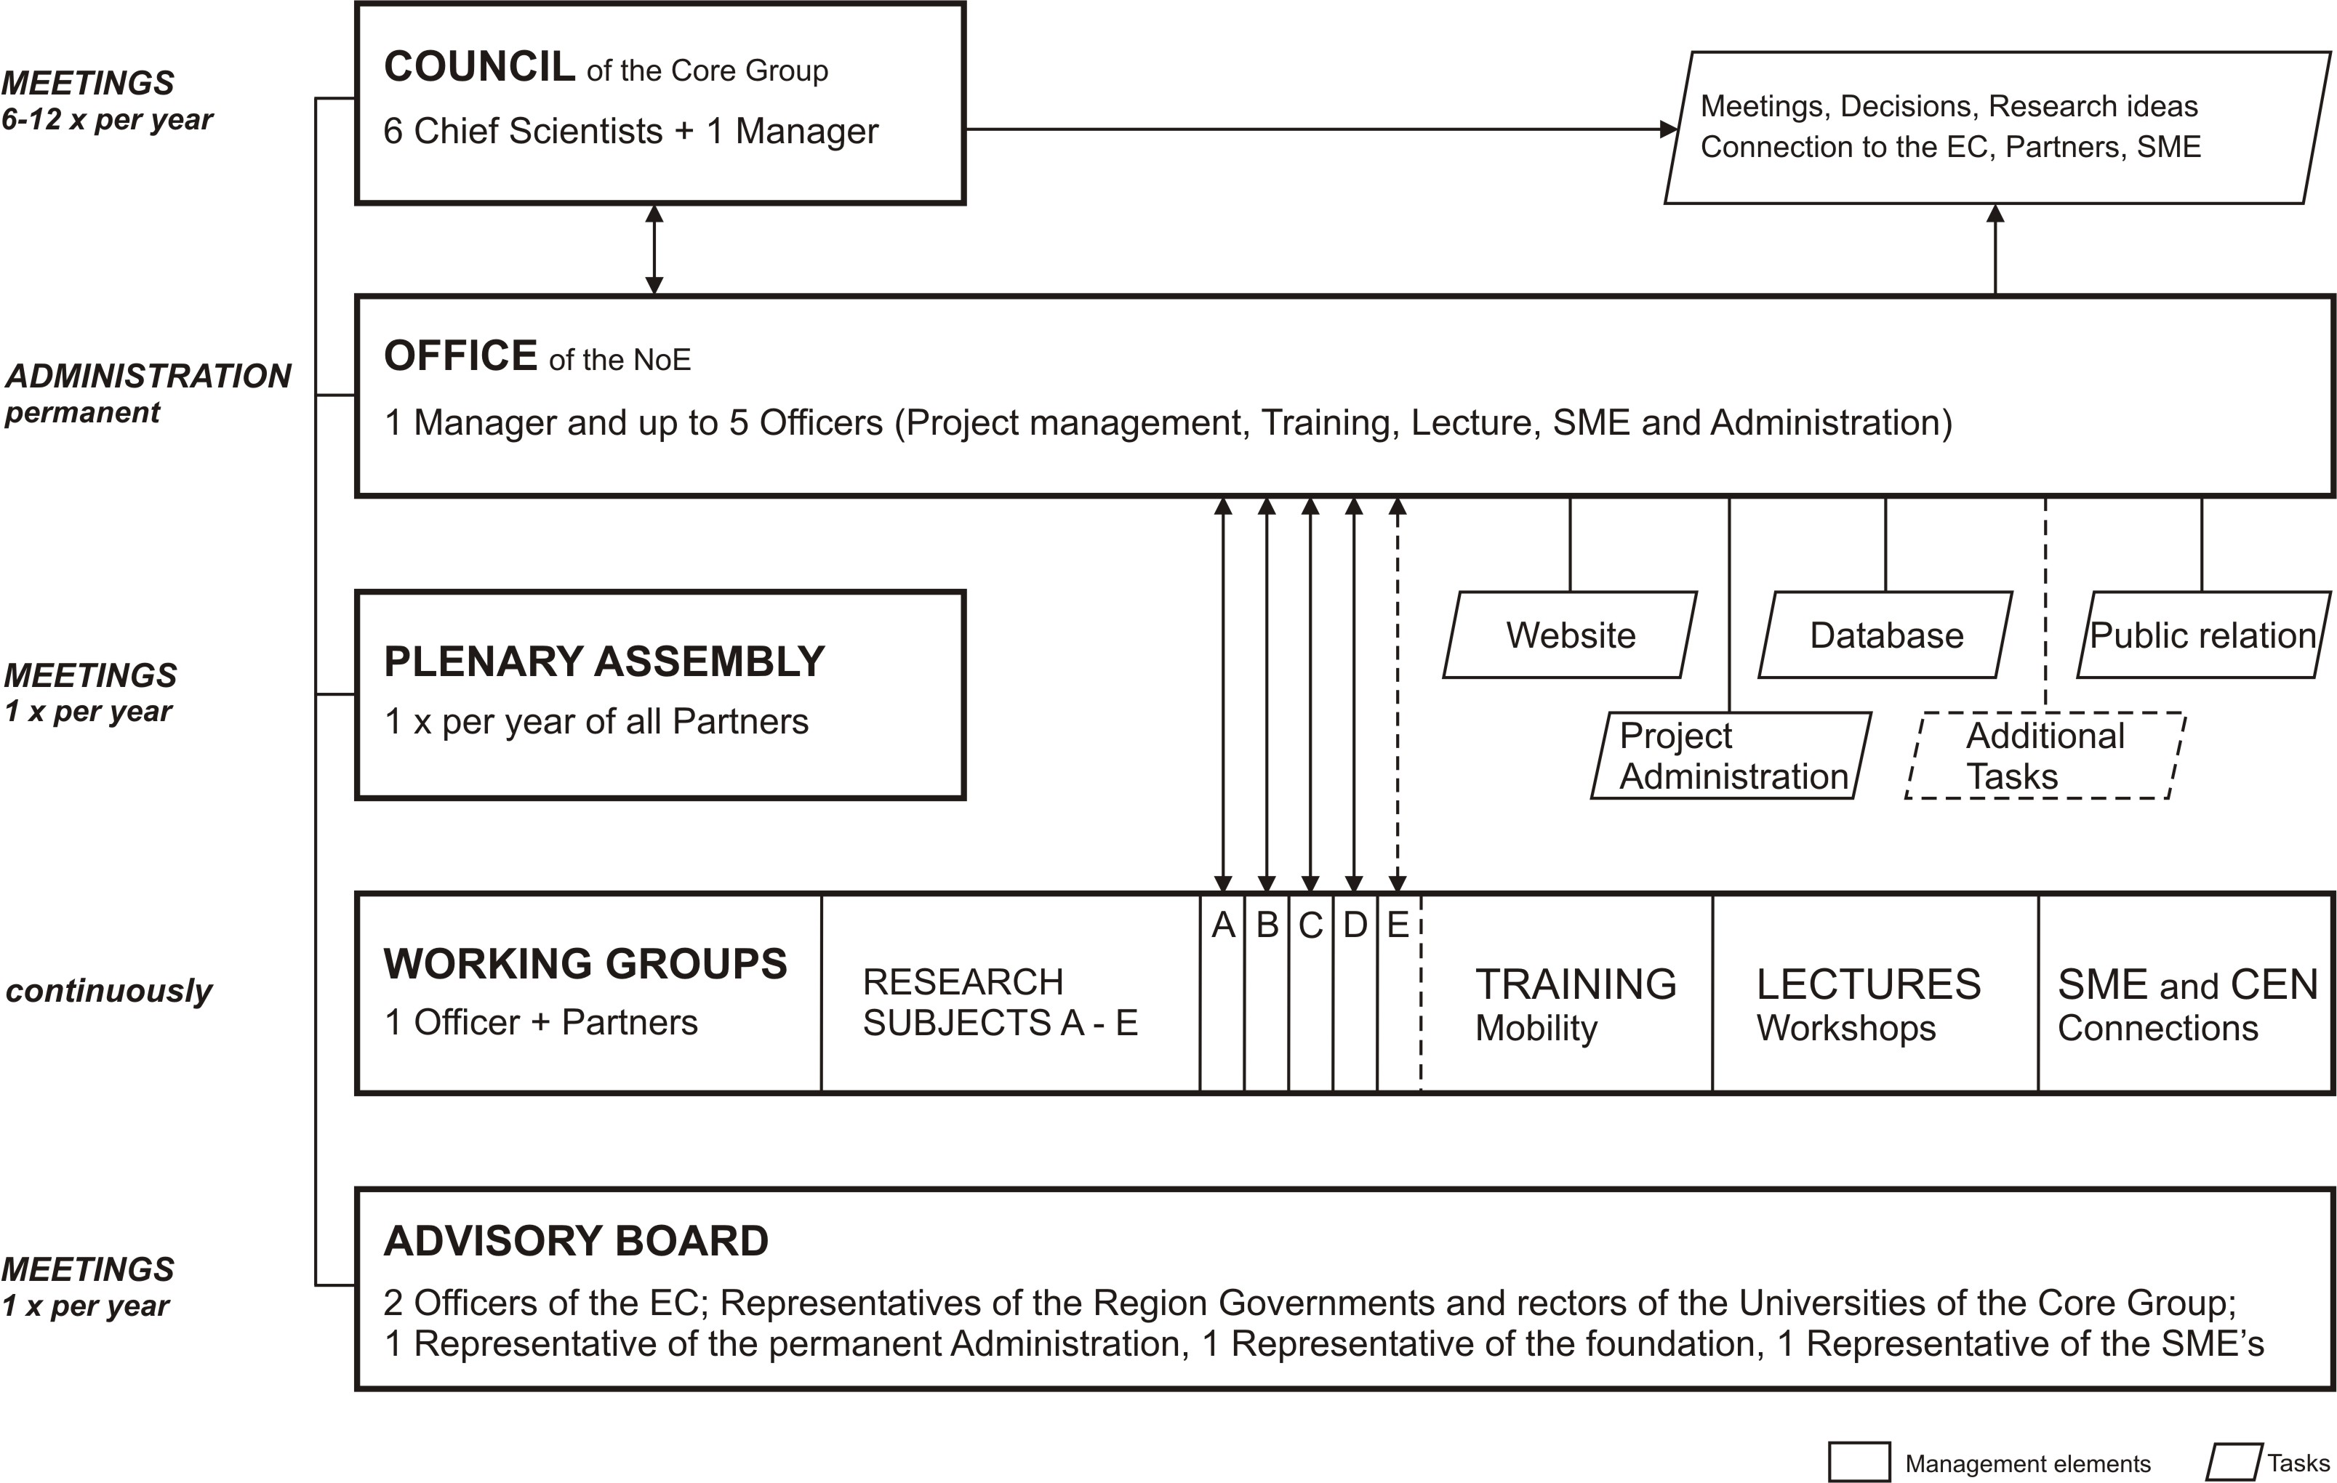

The communication among the partners is supported by a virtual network (web-site) including a knowledge database, regular project meetings and informal workshops.
The tasks of the office are the project management (especially concerning projects between SME’s and universities), the contracts and financial aspects as well as the communication with the European Commission. The work groups are each led by one of the council members and administratively supported by one officer, e.g. the exploitation of the results, trade mark rights, public relation, organization of workshops, seminars, congresses etc.. The advisory board is for the qualified public, and the network represented by the council reports back to it. The board gives advice concerning the quality, competence, cooperation and of course the research objectives in order to lead the NoE to its specified aim within the requirements of the sixth framework program.
Cooperation: More than 30% of the world’s biomaterial production is concentrated in only 10 companies. That´s why special attention needs to be paid to the SME´s within the NoE „BMT“. The task of the NoE is to take up the SME´s ideas and methods of resolution, verify them and bring them to a solution in form of so-called „CRAFT“-Projects. Each method of resolution is to be optimized with the know-how available within the NoE. One of the central objectives of the cooperation between NoE and SME is the organization of several of those smaller RTD-projects or in Cooperative Research projects. Next to the joint research, the SME´s are to offer services in form of measurement engineering, chemical analysis, rapid prototyping, etc.. The cooperation with the SME´s is completed by the training and talks in front of industrial associations, Chambers of Handicraft, etc.
Public relation: The website, i.e. the virtual NoE, is in a very particular form one of the most important elements for the promotion out of the consortium. Furthermore the knowledge and results will still be published in the common way in conferences, academic papers, and scientific journals.
The public relation shall address the interested public, industry and patients via press reports, video clips, and brochures. The promotion is also supported by talks and presentations of the members of the core group and the Office concerning specific topics at universities, industrial associations or on the occasion of trade fairs. The organization of mutual events of the NoE´s with similar themes could be another objective for the future.

